CCNP ROUTE Case Study

Rushi Patel (100615230)

Yash Patel (100621177)

Group 7

2017/11/26

CCNP Route Case Study

**Task 1: Logical Setup1**

**Task 2: Addressing8**

**Task 3: Configure OSPF**16

**Task 4: Configure EIGRP25**

**Task 5: Configure Redistribution and Summarization34**

**Task 6: Configure MP-BGP42**

**Task 7: Configure NAT49**

**Task 8: Connecting Pods 51**

**Task 9: Testing** .**56**

**Security Features: 83**

**Additional Network Changes: 83**

**Show Running Config: 1**

**Task 1: Logical Setup**

1. **Name all devices according to the topology diagram (R1-R4, SW4)**

The snippets below show the name of the corresponding router/switch. Simply write hostname alongside a name for the device to configure a name of the device.

CLI command example:

hostname R1

|  |  |  |  |  |
| --- | --- | --- | --- | --- |
| Router 1 | Router 2 | Router 3 | Router 4 | Switch 4 |
| https://lh5.googleusercontent.com/h3P2rT1hhySbMUm97z_ug8V06gw9Bpuw9e9d278f6T0YybtYioz5hEobN8Ds0lmlvgtrYDroVIgPjHT51TYo5SfjTEcMX2Cs4PPMNyawNJz5Bayim9MeTxW3yPgtxwC76r2whFBK | https://lh6.googleusercontent.com/1sVLhxgGLCzSy_o3dvTB79QCawmJN3x-2XjnARoY6Moi99yQtF4W7cO4CaZmx5q7ps0kQT_q5O4V3VDyrZ7z36pwCEPUxHJkCVkSBzyzrWg6cjQrkym_wOxLXcCdbXnOn4nlpp-X | https://lh5.googleusercontent.com/Hgym05kaQUybsI60tAihzAm0jN2Ln2GNIHQA8nkbSzr_mCGFo7zAuEpWEDcuYlzseXey0UbN0XKBzzf4pMJo9HsreYcz-qii3hjdoEQP3t5ofhX9kEJLOrCOROj6lSDq6NMTHoYd | https://lh5.googleusercontent.com/eQNavvgwps77yOWBS1qbAK8vV5gyLOFBMI5pklOsdjEiJ4DPd-4FR93OCnVL5BQgUrqhw2tj5PnJEPSy5D3HTNxypOvi31j4DoG74F4KoecqgtFZ7-iMMyzSZTYCykrEkk9wPwnE | https://lh4.googleusercontent.com/j8AkL9qoWIJb8b3aiJsMdeO6GDBunCKHFJ_DN2goSwh9jyn6jv9vwPPjNjnIP-iKo_8--Do-NVwIbXfyruy7dK2rmEWoEvkD6ZWMipfYArD1vddOjfoaov4TGPqi_T2zHM9dXRmy |

1. **Be sure to shut down any unused ports on the routers and switches. Failure to do so will result in unexpected route selections.**

CLI Commands to shut down unused interfaces. To shut down a device go on the device and input “shutdown” to administratively shutdown the interface.

|  |  |  |  |  |
| --- | --- | --- | --- | --- |
| R1 | R2 | R3 | R4 | S4 |
| interface gi0/0  shutdown  interface gi0/1  shutdown | interface gi0/1  shutdown  interface s0/0/0  shutdown | interface gi0/1  shutdown  interface s0/0/1  shutdown | interface g0  shutdown  interface s0/0/0  shutdown  interface s0/0/2  shutdown | int range gi1/0/1-18  shutdown  exit  int range gi1/0/21-28  shutdown |

Below the snippets show the shutdown ports for each router/switch. They are shut down so that they do not show up in route selections.

|  |  |
| --- | --- |
| Router 1 | **https://lh3.googleusercontent.com/qk8HAr7znbz6eBSCka7qiUHIw8coC_4wAVMIGhUoqT8c8riY8c4d1E5KSwEok_WEEvOf_3Ou0xjpI45nbaWB4cQ5pwwLeSewVA9n-SD_rdwauaOLU8BV-ZIGVUspWxkxZ8H0NzWZ** |
| Router 2 | **https://lh4.googleusercontent.com/bFbnEUJLox6eI0prZmqr9rrQDCod7c9CMQz5C94Gf-JzNiGpm8GOIEOedLVm8tivJYXYd8mx-L4kKdOgZ9WUF7litmrbcT3f3NdNnjQVi7e_CMrgikApE1duUFVwnrNBjaoFs7AJ** |
| Router 3 | **https://lh4.googleusercontent.com/GAuDS60RVGMVJx2nToAwYp85UJ-EX_5vMqkSF0G4ZrGh8YfgSc_0wKVvqfjSn39lyYPA2QpElxllSe81kdHdCpnhdnUaIr0gDxKX5T4ZSqzp9W8XcMAaLg935UMZiFhTZc4w9Kuq** |
| Router 4 | **https://lh3.googleusercontent.com/O6-kil5T7QoWrC4a9J9Gm0v5qEV0tHkE3RMKc0pM8wGTS04TCoivEz0oZJ5YdAs8eQD8h7HLfQwpmEIXtHqjMzBF0kXJDeryL6fIrihIkpF5PMCcqZ0A2BDk4UkGsxtSGhEjtxQA** |
| Switch 4 | https://lh4.googleusercontent.com/-CJnrWoPjEfwB0TIlItLTyDhJhYnZMEF_a4Rgzl16r7BHYlwkN1wspnAcARg6Q5y2BZT39ev_4RUb5O56jm7tZTlNs3TEahsPPZ_mQoM2twPGmZWeyXvn3kdCh2ev2SYGRaoGK1HThis command will shutdown the unused interfaces in the switch and allow only the needed interfaces to remain active. |

1. **Turn on ipv6 unicast-routing on all routers.**

CLI Command in Global Config Mode for all routers:

* Ipv6 unicast-routing
* IPv6 unicast-routing is used to enable IPv6 routing on routers. This command is used for routers to have IPv6 routes in their routing table so later they can be used to route traffic between routers using IPv6.

|  |  |
| --- | --- |
| Router 1 | https://lh3.googleusercontent.com/AD4t_zBmZnf1E7Bz_XAvSqqTRdx0ajB3eq0fsPat7XCIsHgT7WLXZKOcMcFqH-Pg7KCyMPuReV00me_mQDZy_Qa5HeU2IGKrzek2Rn7g7FczVshHEnn-F50Ybdl7GZt9aBDpVHRw |
| Router 2 | https://lh3.googleusercontent.com/AD4t_zBmZnf1E7Bz_XAvSqqTRdx0ajB3eq0fsPat7XCIsHgT7WLXZKOcMcFqH-Pg7KCyMPuReV00me_mQDZy_Qa5HeU2IGKrzek2Rn7g7FczVshHEnn-F50Ybdl7GZt9aBDpVHRw |
| Router 3 | https://lh3.googleusercontent.com/AD4t_zBmZnf1E7Bz_XAvSqqTRdx0ajB3eq0fsPat7XCIsHgT7WLXZKOcMcFqH-Pg7KCyMPuReV00me_mQDZy_Qa5HeU2IGKrzek2Rn7g7FczVshHEnn-F50Ybdl7GZt9aBDpVHRw |
| Router 4 | https://lh3.googleusercontent.com/AD4t_zBmZnf1E7Bz_XAvSqqTRdx0ajB3eq0fsPat7XCIsHgT7WLXZKOcMcFqH-Pg7KCyMPuReV00me_mQDZy_Qa5HeU2IGKrzek2Rn7g7FczVshHEnn-F50Ybdl7GZt9aBDpVHRw |

1. **Make a VRF called VRF-OSPF on R3, a VRF called VRF-EIGRP on R2, and a VRF called VRF-INET on R4. Make sure you use the vrf definition command, not the ip vrf command.**

For a multiple instance to occur for Router 2, 3, and 4 we must create a VRF. Virtual Routing and Forwarding is created when this command “vrf definition [VRF Name]” is inputted in the CLI. This command enables a router to have a multiple instance.

CLI Commands:

R2:

* vrf definition VRF-EIGRP

R3:

* vrf definition VRF-OSPF

R4:

* vrf definition VRF-INET

|  |  |
| --- | --- |
| Router 2 | **https://lh5.googleusercontent.com/8Hz2V9b-05at7OzWln5aOWUI3CuqYz8H71fj4Kx0eUn4TBOjVBwfsAIxVYvazri3u_QNFcpiDVPfqaS4hCpnPamS2KXoNxaoWfJbMnPh8ROo8Na4Bx_CCHPDQjk70ow528aPw63G** |
| Router 3 | **https://lh4.googleusercontent.com/UnBDpIJJxVAihCxpsnX532NyObdzDUeP76E72xVXw12_FXxekWgXZF8eWyk8YvzS_o2keOL5AGJfxtDRkhj5gLK2lARuLbEnJ0bJsETs4AogczYG-KknvX_oToqVfcrXvQ_yvTY-** |
| Router 4 | **https://lh4.googleusercontent.com/w1kv4qV93VAELKtfU3lqGqIHUcOkws-HG_bADu5ZXLWWzri71fCPVbK90YQKg8IGC9aabTZpsiZpV7GZJYJZ34aOeyx8cNeNH3ieXnZRyQQvsm5msk8kc--NiD4a0xUqCAJ8Q53v** |

1. **Assign route distinguishers 650xx:y where xx is your 2-digit group number (e.g. 01, 02, 03…10, 11, etc.) and y is the router number (e.g. on R2 y = 2) to your VRFs.**

A Route Distinguisher is a unique way of identifying one route from another. Each route in a single VRF is given the same Route Distinguisher so when two routers communicate, it is easy to identify which route belongs to which VRF by its Route Distinguisher.

CLI Commands to configure route distinguisher:

To configure route distinguisher, define it under the initialization of the VRF’s.

R2:

* vrf definition VRF-OSPF

rd 65007:2

R3:

* vrf definition VRF-EIGRP

rd 65007:3

R4:

* vrf definition VRF-INET

rd 65007:4

VRF route distinguisher initialization on R2, R3 and R4

|  |  |
| --- | --- |
| Router 2 | **https://lh5.googleusercontent.com/8Hz2V9b-05at7OzWln5aOWUI3CuqYz8H71fj4Kx0eUn4TBOjVBwfsAIxVYvazri3u_QNFcpiDVPfqaS4hCpnPamS2KXoNxaoWfJbMnPh8ROo8Na4Bx_CCHPDQjk70ow528aPw63G** |
| Router 3 | **https://lh3.googleusercontent.com/rKZVsNy0iW_BZkX_3U67dClf__3i_PYKxaaj_nN6tRBjTb104CLVPDDoBo8mKjHwBkf-mu-BshpZ-OLQ6oSH0HvTykHM8WZYVjzcXsxMUHb0gq2aBq9txKW53rto5mkjUhiL15Vy** |
| Router 4 | **https://lh4.googleusercontent.com/w1kv4qV93VAELKtfU3lqGqIHUcOkws-HG_bADu5ZXLWWzri71fCPVbK90YQKg8IGC9aabTZpsiZpV7GZJYJZ34aOeyx8cNeNH3ieXnZRyQQvsm5msk8kc--NiD4a0xUqCAJ8Q53v** |

1. **Add both the IPv4 and IPv6 address families to each VRF.**

Adding address families in VRF’s on R2, R3 and R4. These address families are created so that the VRF’s are capable of carrying IPv4 and IPv6 addresses for VRF routing.

|  |  |  |
| --- | --- | --- |
| Router 2 | Router 3 | Router 4 |
| **https://lh6.googleusercontent.com/Ng4xmK0qzA5bNZXmbPcP4a9FRMJBHIjJ_cJjdFqzlEWd6B7u8fp5I00AbXFtXbLZia6sqXqYo3XSwhTmOBi5LK7v6Jie2p-Yjg_heEdBRlF76sNfwRbqZWv8G9rX935jmiFqHR4R** | **https://lh3.googleusercontent.com/8eiHdtCk5--KqXsCG1k-ZM2SBIye5r-Ta6Mzfj7-9b2YpIm0WnvhW2vJzomBOZ0DiVBmHb603-IG5ebJcLsstDmQBzl6ckynzCe3o2JfhK-sibzdFeLefYZ85SCMs5OnocdomG1l** | **https://lh5.googleusercontent.com/ms66X0fm_-8HVI7xMQWhj2QN7fdTThl9vn6mefnjFprO-ce0Jx_5XNpfEGJUq7C1l3k1OV8lKgavWT3rpmBos__qSHOI9m2r87FfeL6NkQuIOLfL7pGc5qQY7J0MSrDTUH_JnFO8** |

1. **Assign interfaces to the VRFs as shown in the topology diagram.**

CLI Commands to enable interfaces in each VRF.

|  |  |  |
| --- | --- | --- |
| Router 2 | Router 3 | Router 4 |
| interface loopback1  vrf forwarding VRF-EIGRP  interface loopback2  vrf forwarding VRF-EIGRP  interface Gi0/0.20  vrf forwarding VRF-EIGRP | interface loopback0  vrf forwarding VRF-OSPF  interface loopback1  vrf forwarding VRF-OSPF  interface Gi0/0.10  vrf forwarding VRF- OSPF | interface Gi0/0/1.20  vrf forwarding VRF-INET  interface s0/1/1  vrf forwarding VRF-INET |

Initializing interfaces participating in VRFs. These interfaces need to be explicitly defined with vrf forwarding so that they are associated with the VRF. If the vrf forwarding is not used, it will not become a part of the vrf and therefore will not participate in routing protocols

|  |  |
| --- | --- |
| Router 2 | **https://lh5.googleusercontent.com/8Hz2V9b-05at7OzWln5aOWUI3CuqYz8H71fj4Kx0eUn4TBOjVBwfsAIxVYvazri3u_QNFcpiDVPfqaS4hCpnPamS2KXoNxaoWfJbMnPh8ROo8Na4Bx_CCHPDQjk70ow528aPw63G** |
| Router 3 |  |
| Router 4 |  |

1. **Create the VLANs on the switch as indicated in the topology diagram. Gi1/0/19 & Gi1/0/20 should both be set as static trunk links. Set VTP to Transparent mode.**

For the set of two routers that are connected to the switch a, “set encapsulation dot1q 10 [or] 20” command is also needed alongside the initial configuration on the switch. It is needed so that when a gigabit sub-interface sends a frame to its neighbor, the trunk port configured on the switch can look at the frame and determine its destination.

If the gigabit interface is gi0/0.10 on the router

The command is: encapsulation dot1q 10

If the gigabit interface is gi0/0.10 on the router

The command is: encapsulation dot1q 10

There is one switch but there are 2 connections between routers.

One connection is between R3 (VRF) to R2 and the other connection is between R2(VRF) to R3.

Creating “vlan 10 and vlan 20” in global config mode allows vlans to be made on the switch. Switchport mode trunk allows an interface to be part of the trunking protocol and Switchport trunk allowed 10,20 allows vlan 10 and 20 to participate on the trunking interface.

CLI Commands

Switch 4 Global Config Mode:

vtp mode transparent

Vlan 10

Vlan 20

interface GigabitEthernet1/0/19

switchport trunk allowed vlan 10,20

switchport mode trunk

no shut

exit

interface GigabitEthernet1/0/20

switchport trunk allowed vlan 10,20

switchport mode trunk

no shut

exit

Configuring interface Gi1/0/19 and Gi1/0/20 as trunk links on the switch

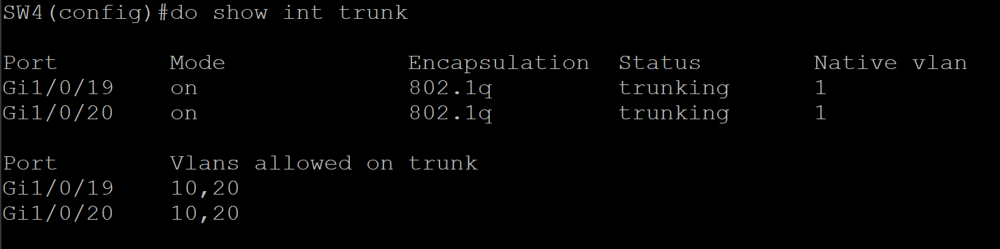

Vlan 10 and 20 are created and they are assigned to Gi1/0/19 and Gi1/0/20

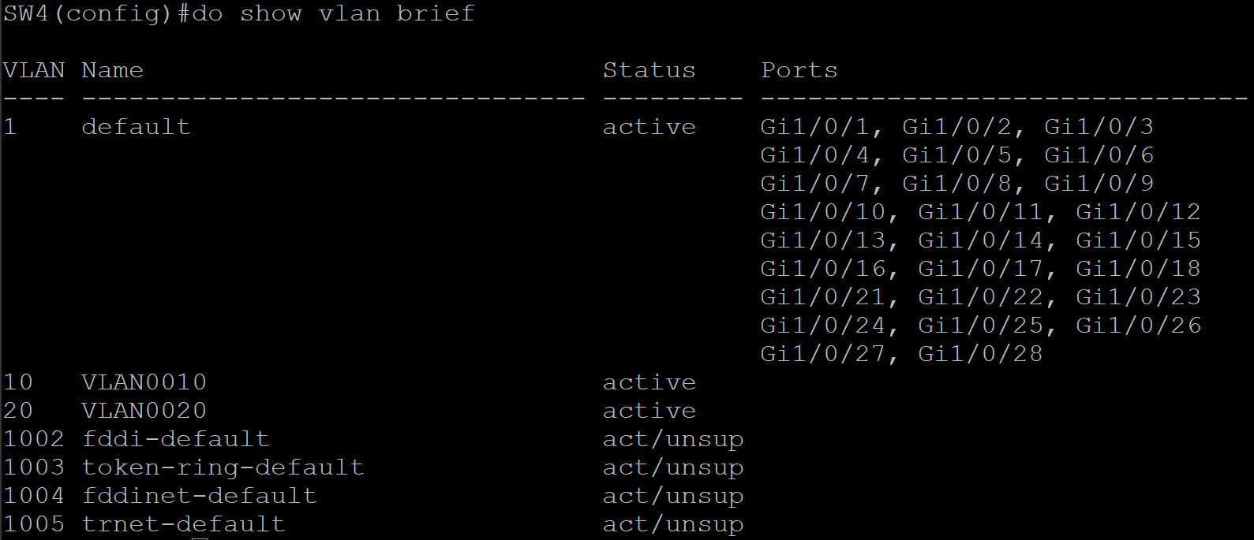

Setting up VTP mode transparent configuration on Switch 4

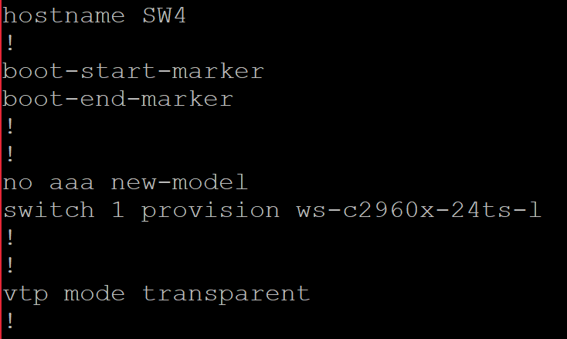

1. **Set the clock rate of each serial link to 64,000 bps on all DCE interfaces.**

Setting up clock rate is essential on routers to determine the bandwidth in which data is sent to other devices. We are setting up a clock rate of 64 0000 bps on all DCE interfaces so all routers with DCE serial interfaces will have a clock rate of 64 000 bps. To set clock rate, it needs to be defined under the interface command.

|  |  |
| --- | --- |
| **Router 1**  Assigning clock rate of 64000 bps on the S0/0/0 DCE interface  CLI Command   * interface serial0/0/0   clock rate 64000 | **https://lh6.googleusercontent.com/dPYZdrXIC7v5ZLjJjqpgvKSSrjT0_7VuZ2Gs7hXgoPzo73UIXX_968R7RODkMRd22EG79isHvnSzs-XXVB5Ek2OPEknR6_nKOdyMtms4Y51kqO4zGvLR-2kMWCQt3fvez5f7ItLu** |
| **Router 2** | No DCE interfaces on Router 2 |
| **Router 3**  Assigned clock rate of 64000 bps on the S0/0/0, S0/1/0, and S0/1/1 DCE interfaces on Router 3  CLI Command   * interface serial0/0/0   clock rate 64000   * interface serial0/1/0   clock rate 64000   * interface serial0/1/1   clock rate 64000 | **https://lh3.googleusercontent.com/27U7rBEeHERd6lqcw0XHJQmC1Dr0AQUvf_qbOB3fCvW_z96-ch86BbWEN-ywyNSkkPWkw3_Ta8PKPJ0maI558y-NbTcT6rhRT5Aow-1J8eA1ePiqBtBBEUmbGzxd9Sb0BSDWmpBL**  **https://lh3.googleusercontent.com/D_p1BBeds8kieo-7Y2beO095c7F1iV7w79KGIGtoP8q1-yj-sPPKqGi0tLs52svGP7J8VNR31-f0u8F_Ln9Dw8s9Gp0jMrSkXjLjICcPBa1PjLx6AYKHiijgqTT2YtPiKJp8oFh-** |
| **Router 4** | No DCE interfaces on Router 4 |

**Task 2: Addressing**

1. **Where possible, design your addressing scheme in a hierarchical method that allows for easy summarization. Create a diagram with your IPv4 and IPv6 addresses clearly labeled, and include it in your final report.**

**IPv4 Addressing - Topology**

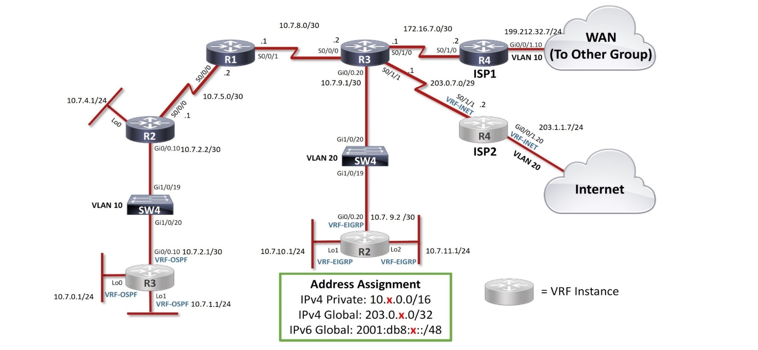

**IPv6 Addressing – Topology**

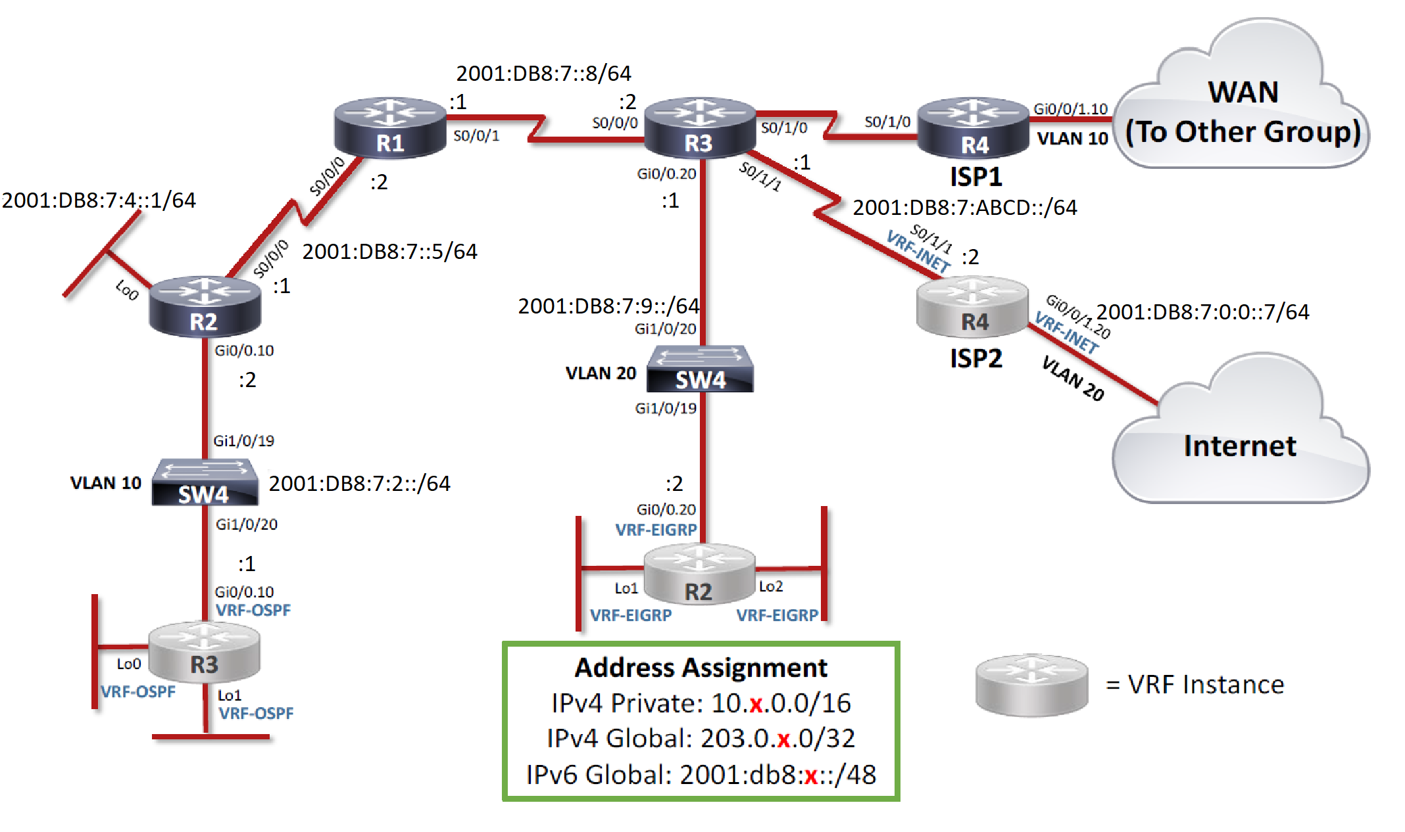

**Addressing Table**

|  |  |  |  |
| --- | --- | --- | --- |
| **Router** | **Interface** | **IPv4 Address** | **IPv6 Address** |
| **R1** | **s0/0/0** | **10.7.5.2/30** | **2001:DB8:7:5::2/64, FE80::1** |
|  | **s0/0/1** | **10.7.8.1/30** | **2001:DB8:7:8::1/64, FE80::1** |
| **R2** | **s0/0/0** | **10.7.5.1/30** | **2001:DB8:7:5::1/64, FE80::2** |
|  | **g0/0.10** | **10.7.2.2/30** | **2001:DB8:7:2::2/64, FE80::2** |
|  | **Lo0** | **10.7.4.1/24** | **2001:DB8:7:4::1/64 , FE80::2** |
| **R3** | **s0/1/1** | **203.0.7.1/29** | **2001:DB8:7:ABCD::1/64, FE80::3** |
|  | **s0/0/0** | **10.7.8.2/30** | **2001:DB8:7:8::2/64, FE80::3** |
|  | **s0/1/0** | **172.16.7.1/30** | **-----------------** |
|  | **g0/0.20** | **10.7.9.1/30** | **2001:DB8:7:9::1/64, FE80::3** |
| **R4** | **s0/1/1** | **203.0.7.2/29** | **2001:DB8:7:ABCD::2/64, FE80::4** |
|  | **s0/1/0** | **172.16.7.2/30** | **-----------------** |
| **(VLAN 10)** | **g0/0/1.10** | **199.212.32.7/24** | **-----------------** |
| **R2-VRF** | **g0/0.20** | **10.7.9.2/30** | **2001:DB8:7:9::2/64, FE80::2** |
|  | **Lo1** | **10.7.3.1/24** | **2001:DB8:7:3::1/64 , FE80::2** |
|  | **Lo2** | **10.7.4.1/24** | **2001:DB8:7:4::1/64, FE80::2** |
| **R3-VRF** | **g0/0.10** | **10.7.2.1/30** | **2001:DB8:7:2::1/64, FE80::3** |
|  | **Lo0** | **10.7.0.1/24** | **2001:DB8:7:0::1/64, FE80::3** |
|  | **Lo1** | **10.7.1.1/24** | **2001:DB8:7:1::1/64, FE80::3** |
| **R4-VRF** | **g0/0/1.20 (vlan 20)** | **203.1.1.7/24** | **2001:DB8:0:0::7/64, FE80::4** |
|  | **s0/1/1** | **203.0.7.2/29** | **2001:DB8:7:ABCD::2/64, FE80::4** |

**2) Assign R3 s0/1/1 the IPv4 address 203.0.x.1/29 and R4 s0/1/1 the IPv4 address 203.0.x.2/29.**

Setting up a connection between S0/1/1 in R3 to S0/1/1 in R4-VRF by assigning IPv4 addresses.

|  |  |  |
| --- | --- | --- |
| Assigning IPv4 to s0/1/1 on R3 and R4 | | CLI Command  Upon entering these commands, the interfaces will come up and form connections with the neighbouring router. R3 and R4 will be able to communicate with each other. |
| Router 3 | https://lh3.googleusercontent.com/xnYYqLHORmeh08tdWwCY96yMwDsowHd4KhcVUSWnFAAwcuZ2TKYLs9kVc3uNy7lWx3fCUKLS_xCfc0YPuT83KHGVA1mAcHi-zujc5khUoxvanfJY46PIgrAnb7pbz0an6ek4bkre | interface s0/1/1  ip address 203.0.7.1 255.255.255.248  no shutdown |
| Router 4 | https://lh3.googleusercontent.com/0BsG13GZ8E8Wlrr9USSMnStCyf1hkPyjiRs7fla-eHe0TxJlcjowJX1oWlJTkTAdh9WHjK4pkD1f-aXFodBfE86VUjy9czVupKh9ZAKPDSR2SiCq561dzL_LsHMiDBUcDwgSynJR | interface s0/1/1  ip address 203.0.7.2 255.255.255.248  no shutdown |

**3) Assign R3 s0/1/0 the IPv4 address 172.16.x.1/30 and R4 s0/1/0 the IPv4 address 172.16.x.2/30.**

Setting up a connection between S0/1/0 in R3 to S0/1/0 in R4 by assigning IPv4 addresses.

|  |  |  |
| --- | --- | --- |
| Assigning IPv4 to s0/1/0 on R3 and R4 | | CLI Command  Upon entering these commands, the interfaces will come up and form connections with the neighbouring router. R3 and R4 will be able to communicate with each other. |
| Router 3 | https://lh6.googleusercontent.com/Cr8Ogj-qDdXRf2XcmNB5nObpOyZGTr2QqR6yUK2ni5LRa3XlXyUXV6CUGxXiay2EN2-6d-7ah8KIA7-H6wHsibFsCNsLqtom-yY1jVDH5iEuNCfNl3mir2NPkn_UlmlnZya-rVlh | interface s0/1/0  ip address 172.16.7.1 255.255.255.248  no shutdown |
| Router 4 | https://lh6.googleusercontent.com/20mKb3wtW_uw2BVta6bNPeFJeu12WOSGobnvmatg6hV4q2ltE8q4rmZpv6R2qhueURdj9LOx2axMrg1XWuAZ547PxZuiu348QZ5rkZy5ESnL5-gX9xuD5-U4C9PYbvcExmyaR6Y3 | interface s0/1/0  ip address 172.16.7.2 255.255.255.248  no shutdown |

**4)  Assign R3 s0/1/1 the IPv6 address 2001:DB8:x:ABCD::1/64 and R4 s0/1/1 the IPv6 address**

Setting up a connection between S0/1/1 in R3 to S0/1/1 in R4 by assigning IPv6 addresses.

|  |  |  |
| --- | --- | --- |
| Assigning IPv6 and link local address to s0/1/1 on R3 and R4 | | CLI Command  Upon entering these commands, the interfaces will come up and form connections with the neighbouring router. R3 and R4 will be able to communicate with each other. |
| Router 3 | https://lh6.googleusercontent.com/RUjFEAGfd-xu1ti1h_1SbsOk02HfugCEbxQA7OYlPX9WEWXBKje014rhC5gPPFfxdJ7UW5nv3dHo0u5G_mJVf98DInpCUXS8MmI7W6OEqgAjWyTIjO8fTVZFwqJ8MpbsRq1RGqan | interface s0/1/1  ipv6 address 2001:DB8:7:ABCD::1/64  no shutdown |
| Router 4 | https://lh5.googleusercontent.com/Kl4s1lgej_EW_pFCF2-ICFQ0OV88kGhNnZydTXlnnLo6ZSPwBQmixYLNSH1Gr6REHqhphgIKjnFFhM0BuzpoYCAbAKLfFTMWOHUsI7tPP-oaBZuJWDYFCJiqa0V46O7h4Y-MpUzz https://lh5.googleusercontent.com/hiPH3EjYKVIXbOJA_NvoAcDwoe_osEDngsTHEAMHXCwbfxFg4ajEa5zr4KkO6cPlJvClPVOJK2j7xuOL-9iqt02EvUFlxxKjcV9uoWmJHNBCd2WZWfXT2H6KpNri5TT0f7HQshHN | interface s0/1/1  ipv6 address 2001:DB8:7:ABCD::2/64  no shutdown |

**5) Assign R4 Gi0/0/1.10 (VLAN 10) the IPv4 address 199.212.32.x/24.**

Assigning IPv4 addresses to sub-interface (Gi0/0/1.10) on R4 for a connection over the WAN link:

|  |  |
| --- | --- |
|  | CLI Command   * interface gi0/0/1.10   ip address 199.212.32.7 255.255.255.0  no shutdown |
| Router 4 | https://lh6.googleusercontent.com/EK6szC-BGMR0KhPT9DZ9zvWa5EeelePnscfgTCxvHrjfuu_sU2VGEUb0f-NlKXLP7q2q49J-FzBoOeoslyGMwKvfhxi3PIVnX-oodUeg2f5i3GsMXkeIVVc0jZ2ZAAaEwOvIPzak |

**6) Assign R4 Gi0/0/1.20 (VLAN 20) the IPv4 address 203.1.1.x/24 and the IPv6 address**

Assigning IPv4 addresses to sub-interface (Gi0/0/1.20) on R4-VRF for a IPv4 connection over the internet:

|  |  |
| --- | --- |
|  | CLI Command   * interface gi0/0/1.10   ip address 203.1.1.7 255.255.255.0  no shutdown |
| Router 4 | https://lh6.googleusercontent.com/EK6szC-BGMR0KhPT9DZ9zvWa5EeelePnscfgTCxvHrjfuu_sU2VGEUb0f-NlKXLP7q2q49J-FzBoOeoslyGMwKvfhxi3PIVnX-oodUeg2f5i3GsMXkeIVVc0jZ2ZAAaEwOvIPzak |

Assigning IPv6 addresses to sub-interface (Gi0/0/1.20) on R4-VRF for a IPv6 connection over the internet:

|  |  |  |
| --- | --- | --- |
| Router 4 | https://lh4.googleusercontent.com/jG3r7zqLKgjOkJjZJWmO9wDzYZzOpsrXfKoXz-fumqsHFYQoq94DI50pX6U4SxdnqDYeV_4-AYx2lWeEAj8733niequ5_8-9QBwpTNPzG7wofsOQu2pGvZjnqN28c3M2H-g6yiFw | CLI Command   * interface gi0/0/1.20   2001:DB8:0:0::7/64  no shutdown |

**7) Assign a /24 IPv4 subnet and a /64 IPv6 subnet to each Loopback interface.**

In this topology, we used a hierarchical addressing scheme to allocate addresses to each device. For the loopbacks we used /24 IPv4’s and /64 IPv6 addresses as per the requirements.

This figure shows the hierarchical addressing scheme applied

|  |  |  |
| --- | --- | --- |
| P2P Connections | IPv4 Addresses | IPv6 Addresses |
| R3-VRF Loopbacks | Lo0 - 10.7.**0**.1/24  Lo1 - 10.7.**1**.1/24 | 2001:DB8:7:**0**::1/64  2001:DB8:7:**1**:1/64 |
| R3-VRF – R2 | 10.7.**2**.1 - 10.7.2.2/30 | 2001:DB8:7:**2**::1/64 - 2001:DB8:7:2::2/64 |
| R2 Loopback | Lo0 - 10.7.**4**.1/24 | 2001:DB8:7:**4**::1/64 - 2001:DB8:7:4::2/64 |
| R2 – R1 | 10.7.**5**.1 - 10.7.5.2/30 | 2001:DB8:7:**5**::1/64 - 2001:DB8:7:5::2/64 |
| R1 – R3 | 10.7.**8**.1 - 10.7.8.2/30 | 2001:DB8:7:**8**::1/64 - 2001:DB8:7:8::2/64 |
| R3 – R2-VRF | 10.7.**9**.1 - 10.7.9.2/30 | 2001:DB8:7:**9**::1/64 - 2001:DB8:7:9::2/64 |
| R2-VRF Loopback | Lo1 - 10.7.**10**.1/24  Lo2 - 10.7.**11**.1/24 | 2001:DB8:7:**10**::1/64  2001:DB8:7:**11**::1/64 |

|  |  |  |
| --- | --- | --- |
| R2: CLI Command | R2 (VRF): CLI Command | R3 (VRF): CLI Command |
| interface loopback0  ip address 10.7.4.1 255.255.255.0  ipv6 address 2001:DB8:7:4::1/64 | interface loopback1  ip address 10.7.10.1 255.255.255.0  ipv6 address 2001:DB8:7:10::1/64  interface loopback2  ip address 10.7.11.1 255.255.255.0  ipv6 address 2001:DB8:7:11::1/64 | interface loopback0  ip address 10.7.0.1 255.255.255.0  ipv6 address 2001:DB8:7:0::1/64  interface loopback1  ip address 10.7.1.1 255.255.255.0  ipv6 address 2001:DB8:7:1::1/64 |

|  |  |  |
| --- | --- | --- |
|  | **/24 IPv4 Loopback** | **/64 IPv6 Loopback** |
| **Router 2** |  |  |
| **Router 2 (VRF)** | https://lh4.googleusercontent.com/7-K-UB0ZqtiJBx1qY0NuVTiIhYmRq9LqClVA5I3xGmsl0vhulat-8_5-9ErlmYGGUpWDpfHk7SZ3AV_fuq7fWVH7m13-_BLgpAJnP_jwBDVeX3q16COGwZlUZQizw5NCRZZq0M0E  https://lh3.googleusercontent.com/_dtdPNZDz710ODttAlHNrQOSh8dtU1zydMQZkasRgL06X-QCm7Tr841GSYKXmxqkIzdr92qmd22_NcFiBW8xLnVov6lhCLH0JwBaoUopUxcX8bTtPRm7qxyBxldhZpJ5twxKdxrm | https://lh4.googleusercontent.com/VOIHzvI1A0uy4wIJ8GZAFQzsItImfv616Tt1N9s40Ud88yUo_2Npru8RF-NYlBAe_4ycbSwgUeOxhiYan7Du3mZ4Uf83QJwzW2o4YKvtRvld5FjNjz9SKKyPfXayNq7Hrpa78S57  https://lh3.googleusercontent.com/a1mZ6Cgb1SjxuPmG8DwUd3q46p7moj5L13lm2ATObLCo2g1a1XjOCHrpCFH4v-z20BfKxlY4ArdGOzRINe5Pt4yyk0vesU7bDBPTgyqdDcETrw-3zAb7PVv7bGa1dnpbPGWyQfyh |
| **Router 3 (VRF)** | https://lh5.googleusercontent.com/z-lWI-b28TPOu6rHhipv8B0plXt7Rz38q91bFaZRAcOB177_s3HL7MP-NEndy3aKycVyU_Jppk_lcaXXAUU2Jol4kICvimj1zy-rs2x55BP_i4j9DfSNDzeJ_2g0Ak1P5a7pzqer  https://lh4.googleusercontent.com/rIwBubEkZJJBWk6leT6r9gAgKH2gWiCjSHWGJN9JDn7UiPQ2AP41_JNHBKLA8YriBoS71_nDz3v8TPyRJe6EOOaaailCpoS0ZUuP4Rr_4fnMf2QmOC5MAUfz8UqZikLeLFxIY5sh | https://lh3.googleusercontent.com/tnSrcvLfwGtXwu-vh7RyLAquXChiFFj--JRR-m_31WFndcmPt8jkKyiKARVVARP4dy-vsQ-zu8qstypG1pKhjNwQGUMiHRqGUUT3HFutegsJPi0G1vSqWLuCJZKq8m53VbadYO5j  https://lh4.googleusercontent.com/7UpSX90W1g7gF96r4f7yZlSWqpUplWHs7JnYfUHF030AZRPfhLelOGN4fG5E4UWYEpJg5-v2pQBkIDyxWrwbTKux4PerI2GpNNGO1AvKRkpJUffWqLQmx4wnHtpWyAFF8Vy7mgZW |

**8)** **Assign a /30 IPv4 subnet and a /64 IPv6 subnet to each point-to-point link between routers. Use the pools shown in the diagram. Give the lower numbered router the first address in each range, and the other router the second address.**

Routers are assigned a /30 IPv4 subnet because they are point-to-point links and therefore do not need more than 4 IPv4s (2 addresses for hosts and 2 more for allocating network and broadcast address). For this topology we have assigned in a hierarchical fashion so addresses are summarized as efficiently as possible in OSPF and EIGRP redistribution process. For the addressing scheme we started allocating /30 and /64 hierarchically from R3-VRF to R2-VRF.

|  |  |  |
| --- | --- | --- |
| P2P Connections | IPv4 Addresses | IPv6 Addresses |
| R3-VRF Loopbacks | Lo0 - 10.7.**0**.1/24  Lo1 - 10.7.**1**.1/24 | 2001:DB8:7:**0**::1/64  2001:DB8:7:**1**:1/64 |
| R3-VRF – R2 | 10.7.**2**.1 - 10.7.2.2/30 | 2001:DB8:7:**2**::1/64 - 2001:DB8:7:2::2/64 |
| R2 Loopback | Lo0 - 10.7.**4**.1/24 | 2001:DB8:7:**4**::1/64 - 2001:DB8:7:4::2/64 |
| R2 – R1 | 10.7.**5**.1 - 10.7.5.2/30 | 2001:DB8:7:**5**::1/64 - 2001:DB8:7:5::2/64 |
| R1 – R3 | 10.7.**8**.1 - 10.7.8.2/30 | 2001:DB8:7:**8**::1/64 - 2001:DB8:7:8::2/64 |
| R3 – R2-VRF | 10.7.**9**.1 - 10.7.9.2/30 | 2001:DB8:7:**9**::1/64 - 2001:DB8:7:9::2/64 |
| R2-VRF Loopback | Lo1 - 10.7.**10**.1/24  Lo2 - 10.7.**11**.1/24 | 2001:DB8:7:**10**::1/64  2001:DB8:7:**11**::1/64 |

The figure above shows the hierarchy that took place in allocating /30 and /64 in the topology. We matched the subnets of IPv6 to the subnets of IPv4 for simplicity and also to easily map of which subnet belongs to which router.

**9) Statically configure link-local addresses on each router interface to be FE80::y, where y is the router number (e.g. R3 would have FE80::3 on all of its interfaces).**

Since IPv6 is enabled across routers, link-local addresses are needed. For IPv6 features to work, most of the time link-local addresses are needed. One main reason why it is needed is because of neighbor discovery between IPv6 addresses.

|  |  |  |  |
| --- | --- | --- | --- |
| R1: CLI Command | R2: CLI Command | R3: CLI Command | R4: CLI Command |
| Interfaces s0/0/0  ipv6 address FE80::1  interface s0/0/1  ipv6 address FE80::1 | Interface gi0/0.10  ipv6 address FE80::2  Interface gi0/0.20  ipv6 address FE80::2  Interfaces s0/0/0  ipv6 address FE80::2  interface loopback0  ipv6 address FE80::2  interface loopback1  ipv6 address FE80::2  interface loopback2  ipv6 address FE80::2 | Interface gi0/0.10  ipv6 address FE80::3  Interface gi0/0.20  ipv6 address FE80::3  interface loopback0  ipv6 address FE80::3  interface loopback1  ipv6 address FE80::3  Interfaces s0/0/0  ipv6 address FE80::3  Interfaces s0/1/0  ipv6 address FE80::3  Interfaces s0/1/1  ipv6 address FE80::3 | Interface gi0/0/1.10  ipv6 address FE80::4  Interface gi0/0/1.20  ipv6 address FE80::4  Interfaces s0/1/0  ipv6 address FE80::4  Interfaces s0/1/1  ipv6 address FE80::4 |

|  |  |
| --- | --- |
| Router 1  Assigning Link-local addresses in all interfaces participating in Router 1 | https://lh6.googleusercontent.com/Uc1KIxbp-kSSRQ2Wh4Lt4Ok3bGE6o_y9X4jL1l2iTYu93JjNcftAQZThMy8WvWRsfbYpnmMsH_0AXIK6XDLiwwjCYeey_ALZAQW7X6E_UIEKC2iVul3e5sm25XAZ6iBep2Cfi7mh |
| Router 2  Assigning Link-local addresses in all interfaces participating in Router 2 |  |
| Router 3  Assigning Link-local addresses in all interfaces participating in Router 3 | https://lh6.googleusercontent.com/FBb4SaK0ECnRje7XIVq2GE7uyCU4mjiymLfrfbTwiDFnd2MY7ckp9DhOKsrpoK6AzHZ2nu9Qkv4zJ9yEVHTGfoM9tF400hqrNAaEhzArWeaHN8sJSW6pI6u0OI-imBWVAo4V62UF |
| Router 4  Assigning Link-local addresses in all interfaces participating in Router 4 | **https://lh5.googleusercontent.com/ZreDY0v6CX-43teGcl3xklyU5dkXg9_u5uZyX2-Mkoss5xyQBXxO3oTjq2I-d7YevEGbK1-jpS4LISyPpL-tJA6aerTFPiynIsvLGe1yeILpO4MO_jnWSAk865ISF9VbVlBOiwuM** |

**Task 3: Configure OSPF**

1. **Use a process number equal to your group number.**

Configuring OSPFv3 process ID as 7 for each router that participate in opsfv3 process

We are configuring process ID as 7 to specify which interfaces will belong to ospfv3 7 process, since we can have different ospfv3 processes running on each interface

To enable ospfv3 process 7 you just enter global configuration mode and over there just type [router ospfv3 (process ID)] and it will enable ospfv3 process

|  |  |
| --- | --- |
| R1: Process id (PID) is 7 |  |
| R2: Process id (PID) is 7 |  |
| R3 (VRF): Process id (PID) is 7 |  |

|  |
| --- |
| router ospfv3 7 |

**CLI Commands:**

1. **Set the bandwidth of all interfaces appropriately.**

Configuring each interface’s bandwidth to 64,000 bps for those who are participating in ospfv3 process

In this step, we configured our bandwidth on each interface to 64,000 bps to make sure all the routers select accurate path to the destination since bandwidth is use in metric calculation, which is use to identify best path to the destination

To configure bandwidth enter global mode, type your interface and then just type in [bandwidth 64] command, and it will increase or decrease bandwidth to assigned value

|  |  |
| --- | --- |
| R1:Bandwidth set as 64 on s0/0/0 |  |
| CLI Commands: | R1:  interface Serial0/0/0  bandwidth 64 |
| R2:  Bandwidth set as 64 on s0/0/0  Bandwidth set as 64 on Gi0/0.10  Bandwidth set as 64 on loopback0 |  |
| CLI Commands: | R2:  interface Serial0/0/0  bandwidth 64  interface Gi0/0.20  bandwidth 64  interface Loopback0  bandwidth 64 |
| R3 (VRF):  Bandwidth set as 64 on Gi0/0.10  Bandwidth set as 64 on loopback0  Bandwidth set as 64 on loopback1 |  |
| CLI Commands | R3: VRF-OSPF  interface Loopback0  bandwidth 64  interface Loopback1  bandwidth 64  interface Gi0/0.10  bandwidth 64 |

1. **Change the OSPF reference bandwidth to 100 Gbps.**

Configuring Reference bandwidth on OSPFv3 for each router

We set our reference bandwidth to 100000 mbps on each OSPFv3 router so we can have an increased cost of route to ospf neighbors

To configure reference bandwidth we first enter into ospfv3 process and under that, we type [auto-cost reference-bandwidth 100000]

|  |  |
| --- | --- |
| R1: Reference bandwidth |  |
| CLI Commands: | R1:  router ospfv3 7  auto-cost reference-bandwidth 100000 |
| R2: Reference Bandwidth |  |
| CLI Commands: | R2:  router ospfv3 7  auto-cost reference-bandwidth 100000 |
| R3 (VRF): Reference Bandwidth |  |
| CLI Commands: | R3: VRF-OSPF  router ospfv3 7  auto-cost reference-bandwidth 100000 |

1. **Enable OSPFv3 on R1, R2, and R3 for both IPv4 and IPv6 address families, on the interfaces indicated in the diagram. (Note that the commands all start with "ospfv3", not the older "ipv6 router ospf" or "ip ospf" commands).**

Enabling OSPFv3 for ipv4 and ipv6 address-families

We are using address-families to make sure we have separate ipv4 and ipv6 address families. All ipv4 related configuration goes under ipv4 address family and all ipv6 related configuration goes under ipv6 address family this way we have more room to keep ipv4 and ipv6 separate, and reduce the complexity when there are two or more ospfv3 processes are running on an interface

To Configure, we first enter into ospfv3 process and then add the [address-family ipv4/ipv6 unicast ] to enable them under ospfv3 process. Also to enter vrf address families you must enter [address-family ipv4/ipv6 unicast vrf (vrf-name) ]

|  |  |
| --- | --- |
| R1:  IPv4 address Family  IPv6 address family |  |
| CLI Commands: | R1:  router ospfv3 7  address-family ipv4 unicast  exit-address-family  address-family ipv6 unicast  exit-address-family |
| R2:  IPv4 address Family  IPv6 address family |  |
| CLI Commands: | R2:  router ospfv3 7  address-family ipv4 unicast  exit-address-family  address-family ipv6 unicast  exit-address-family |
| R3 (VRF):  IPv4 address Family  IPv6 address family |  |
| CLI Commands: | R3: VRF-OSPF  router ospfv3 7  address-family ipv4 unicast vrf VRF-OSPF  exit-address-family  address-family ipv6 unicast vrf VRF-OSPF  exit-address-family |

1. **Use the router number as the router ID (e.g., on R1 use 1.1.1.1). Use this router ID for IPv4, IPv6, and the VRF address families as applicable.**

Configuring router-id on each router under ipv4, ipv6 and vrf ipv4/ipv6

We decided to use router-id here in the ospf process to make sure all router are uniquely identified inside the Autonomous System

To configure router-id you must enter ospfv3 process and then enter into ipv4/ipv6 address family or ipv4/ipv6 vrf (vrf-name) address family and type [router-id (32-bit number: 2.2.2.2)] to specify that particular router uniquely in the whole Autonomous System

|  |  |
| --- | --- |
| **R1: Router-id (1.1.1.1)**  **IPv4 address family**  **IPv6 address family** |  |
| **CLI Commands:** | R1:  router ospfv3 7  address-family ipv4 unicast  router-id 1.1.1.1  exit-address-family  address-family ipv6 unicast  router-id 1.1.1.1  exit-address-family |
| **R2: Router-id (2.2.2.2)**  **IPv4 address family**  **IPv6 address family** |  |
| **CLI Command:** | R2:  router ospfv3 7  address-family ipv6 unicast  router-id 2.2.2.2  exit-address-family  address-family ipv6 unicast  router-id 2.2.2.2  exit-address-family |
| **R3 (VRF): Router-id (3.3.3.3)**  **IPv4 address family**  **IPv6 address family** |  |
| **CLI Commands:** | R3:  router ospfv3 7  address-family ipv4 unicast vrf VRF-OSPF  router-id 3.3.3.3  exit-address-family  address-family ipv6 unicast vrf VRF-OSPF  router-id 3.3.3.3  exit-address-family |

1. **Change the network type on the loopback interfaces so that the routes are advertised with the correct subnet mask.**

Configure network type on all loopbacks under ospfv3 process to point-to-point

Purpose of point-to-point is to make sure that address has advertised with right subnet instead of /32

To configure network type to point-to-point you can just go under a loopback interface you want as point-to-point and type in (ospfv3 network point-to-point) command this will advertised addresses with right subnet instead of /32

|  |  |
| --- | --- |
| **R2: Loopback0**  **Proof of network type to point-to-point** |  |
| **CLI Commands:** | R2:  interface Loopback0  ospfv3 network point-to-point  exit |
| **R3 (VRF): Loopback0 and Loopback1**  **Proof of network type to point-to-point** |  |
| **CLI Commands:** | R3: VRF-OSPF  interface Loopback0  ospfv3 network point-to-point  exit  interface Loopback1  ospfv3 network point-to-point  exit |

1. **Configure all Loopback interfaces as passive.**

Configuring each loopback interface as a passive interface in ospfv3

We are configuring passive-interface on each loopback since we are not forming neighbor adjacency between/using loopbacks. We set loopback interfaces as passive to prevent routing updates from being sent out by loopbacks to all of its neighbors and also, to reduce consumption of bandwidth by sending out those updates

To configure an interface to passive you should enter ospfv3 process then, enter into ipv4/ipv6 address families, and type in passive-interface (interface)

|  |  |
| --- | --- |
| **R2:Proof of all loopbacks to passive**  **Loopback0** |  |
| **CLI Commands:** | R2:  router ospfv3 7  address-family ipv4 unicast vrf VRF-OSPF  passive-interface Loopback0  exit-address-family  address-family ipv6 unicast vrf VRF-OSPF  passive-interface Loopback0  exit-address-family  exit |
| **R3 (VRF): Proof of all loopbacks to passive**  **Loopback0**  **Loopback1** |  |
| **CLI Commands:** | R3:  router ospfv3 7  address-family ipv4 unicast vrf VRF-OSPF  passive-interface Loopback0  passive-interface Loopback1  exit-address-family  address-family ipv6 unicast vrf VRF-OSPF  passive-interface Loopback0  passive-interface Loopback1  exit-address-family |

1. **Configure area x as a totally stubby area for both IPv4 and IPv6.**

Configuring area 7 as totally stubby area in both ipv4 and ipv6 address-families

In this step, we are configuring a totally stubby area on R3-vrf and R2 to only allow intra-area LSAs to be exchanged and, to block any external type 5 LSAs, summary type 3 LSAs, and type 4 LSAs coming into the area. Using this method, we can reduce the amount of routes we have in our routing table and only have one default route on ABR (R2), which is a path to any route unknown in totally stub area. This way we can increase stability of the area since, totally stubby area will limit the flow of traffic coming into the area.

To configure totally stubby area we first enter ospfv3 process, in our next step we enter a specific address family (ipv4/ipv6), then we type area 7 stub no-summary command which will activate the specified area as totally stubby

|  |  |
| --- | --- |
| **R2: Area 7**  **Configuring Gi0/0.10 as totally stubby in area 7**  **IPv4 address family**  **IPv6 address family** |  |
| **CLI Commands:** | R2:  router ospfv3 7  address-family ipv4 unicast  area 7 stub no-summary  exit-address-family    address-family ipv6 unicast  area 7 stub no-summary  exit-address-family |
| **R3 (VRF): Area 7**  **Configuring area 7 as totally stubby area**  **IPv4 address family**  **IPv6 address family** |  |
| **CLI Commands:** | R3: VRF-OSPF  router ospfv3 7  address-family ipv4 unicast vrf VRF-OSPF  area 7 stub  exit-address-family  address-family ipv6 unicast vrf VRF-OSPF  area 7 stub  exit-address-family |

1. **Note that on R3 in the VRF address family (IPv4 and IPv6) you must include the following command for your routes to show up in the routing table: capability vrf-lite**

* Purpose of configuring capability vrf-lite is to make sure that packets are sent out of the area using correct LSAs instead of having type 3 LSAs which will only work inter area
* [capability vrf-lite] applies multi-VRF capability to the ospf process

|  |  |
| --- | --- |
| **R3 (VRF): Configure capability vrf-lite**  **IPv4 address family** |  |
| **CLI Command:** | router ospfv3 7  address-family ipv4 unicast vrf VRF-OSPF  capability vrf-lite |
| **R3 (VRF): Configure capability vrf-lite**  **IPv6 address family** |  |
| **CLI Command: This command is configured under ospfv3 process in each ipv4 and ipv6 address-family** | router ospfv3 7  address-family ipv6 unicast vrf VRF-OSPF  Capability vrf-lite |

**Task 4: Configure EIGRP**

1. **Use an AS number equal to your group number.**

Configuring Autonomous number for EIGRP router protocol

The purpose of assigning Autonomous system (AS) number to EIGRP is to identify that this EIGRP is an internal EIGRP protocol running inside the Autonomous system defined

To configure Autonomous system enter EIGRP Named mode, then type address-family ipv4/ipv6 unicast autonomous-system (AS number) this will assign an Autonomous system (AS) number to EIGRP

|  |  |
| --- | --- |
| **R1: Configuring AS for IPv4 and IPv6** |   |
| **CLI Commands:** | R1:  router eigrp CASE2017    address-family ipv4 unicast autonomous-system 7  exit-address-family    address-family ipv6 unicast autonomous-system 7  exit-address-family |
| **R2 (VRF): Configuring AS for IPv4 and IPv6** |   |
| **CLI Commands:** | R2: VRF-EIGRP  router eigrp CASE2017    address-family ipv4 unicast autonomous-system 7 vrf VRF-EIGRP  exit-address-family    address-family ipv6 unicast autonomous-system 7 vrf VRF-EIGRP  exit-address-family |
| **R3: Configuring AS for IPv4 and IPv6** |   |
| **CLI Commands:** | R3:  router eigrp CASE2017    address-family ipv4 unicast autonomous-system 7  exit-address-family    address-family ipv6 unicast autonomous-system 7  exit-address-family |

1. **Set the bandwidth of all interfaces appropriately.**

Configure bandwidth as 64,000 bps on each interface that participate in EIGRP

Purpose of configuring bandwidth is to increase or decrease the flooding of traffic into EIGRP through an interface so by setting bandwidth to 64,000 bps it will reduce the amount of traffic flow into EIGRP

To configure bandwidth you must enter in an interface that belongs to EIGRP and then under the interface type bandwidth (bandwidth-number) command and it will set bandwidth to whatever number you entered.

|  |  |
| --- | --- |
| **R1: Configuring bandwidth to 64 on s0/0/1** |  |
| **R2 (VRF): Configuring bandwidth to 64 on:**  **loopback1**  **loopback2**  **gi0/0.20** |    |
| **R3: Configuring bandwidth to 64 on**  **s0/0/0**  **gi0/0.20** |  |

**CLI Commandss:**

|  |
| --- |
| R3:  interface GigabitEthernet0/0.20  bandwidth 64  exit  interface Serial0/0/0  bandwidth-percent 64  exit |
| R1:  interface Serial0/0/1  bandwidth 64  exit |
| R2: VRF-EIGRP  interface Loopback1  bandwidth 64  exit  interface Loopback2  bandwidth 64  exit  interface GigabitEthernet0/0.20  bandwidth 64  exit |

1. **Enable EIGRP Named Mode on R1, R2, and R3, for both IPv4 and IPv6, as indicated in the diagram. Name your EIGRP process CASE2017**

Configure EIGRP named mode on each router for both ipv4/ipv6 address family

We are using EIGRP named mode to reduced complexity of configuring both ipv4 and ipv6 since it takes two different router configuration mode to configure ipv4 and ipv6. Hence, to eliminate this problem we will use named mode so we can keep ipv4 and ipv6 separately under one EIGRP process instead of two.

To configure EIGRP named mode we type router eigrp [(name of you eigrp)] now under that we will create our ipv4/ipv6 address-families with specified AS which we in our first step

|  |  |
| --- | --- |
| **R1: Enabling EIGRP Named mode** |   |
| **R2 (VRF): Enabling EIGRP Named mode** |   |
| **R3: Enabling EIGRP Named mode** |   |

**CLI Commands:**

|  |
| --- |
| R1, R2: VRF-EIGRP , R3:  router eigrp CASE2017 |

1. **Use /32 wlidcard masks for each interface in your network commands.**

Configuring 0.0.0.0 wildcard mask for each network command

(why)

To configure /32 wildcard mask we enter into EIGRP named mode and then we enter into address-family for ipv4 under that we use network command ( network-to-advertise wildcard-mask)

|  |  |
| --- | --- |
| **R1: /32 wildcard mask for interface s0/0/1** |  |
| **CLI Commands:** | R1:  router eigrp CASE2017  address-family ipv4 unicast autonomous-system 7  network 10.7.8.1 0.0.0.0  exit-address-family |
| **R2 (VRF): /32 wildcard mask for interface gi0/0.20** |  |
| **CLI Commands:** | R2: VRF-EIGRP  router eigrp CASE2017  address-family ipv4 unicast autonomous-system 7  network 10.7.9.2 0.0.0.0  network 10.7.10.1 0.0.0.0  network 10.7.11.1 0.0.0.0  exit-address-family |
| **R3: /32 wildcard mask for interfaces**  **gi0/0.20**  **s0/0/0** |  |
| **CLI Commands:** | R3:  router eigrp CASE2017  address-family ipv4 unicast autonomous-system 7  network 10.7.8.2 0.0.0.0  network 10.7.9.1 0.0.0.0  exit-address-family |

1. **Use the router number as the router ID (e.g., on R1 use 1.1.1.1). Use this router ID for IPv4, IPv6, and the VRF address families as applicable**

Configuring router-id for each router

In this step we will configure router Id to make sure all routers are identified uniquely inside the network by all of the other router

To configure router ID we will enter EIGRP named mode first, secondly we will enter into each ipv4/ipv6 address-families and just type [eigrp router-id (32-bit number)] command which will assign a router-id to that router

|  |  |
| --- | --- |
| **R1: Router-id (1.1.1.1)**  **IPv4 address family**  **IPv6 address family** |  |
| **CLI Commands:** | R1:  router eigrp CASE2017  address-family ipv4 unicast autonomous-system 7  eigrp router-id 1.1.1.1  exit-address-family  address-family ipv6 unicast autonomous-system 7  eigrp router-id 1.1.1.1  exit-address-family |
| **R2 (VRF): Router-id (2.2.2.2)**  **IPv4 address family**  **IPv6 address family** |  |
| **CLI Commands:** | R2: VRF-EIGRP  router eigrp CASE2017  address-family ipv4 unicast vrf VRF-EIGRP autonomous-system 7  eigrp router-id 2.2.2.2  exit-address-family  address-family ipv6 unicast vrf VRF-EIGRP autonomous-system 7  eigrp router-id 2.2.2.2  exit-address-family |
| **R3: Router-id (3.3.3.3)**  **IPv4 address family**  **IPv6 address family** |  |
| **CLI Commands:** | R3:  router EIGRP CASE2017  address-family ipv4 unicast autonomous-system 7  EIGRP router-id 3.3.3.3  exit-address-family  address-family ipv6 unicast autonomous-system 7  EIGRP router-id 3.3.3.3  exit-address-family |

1. **By default, all IPv6 interfaces participate in EIGRP Named Mode. Remove EIGRP from interfaces where it is not required (check show ipv6 EIGRP interface).**

Shutdown all unwanted ipv6 interfaces that are participating in EIGRP named mode

Purpose of this is to make sure only necessary interfaces are participating in ipv6 EIGRP named mode

To shutdown all unwanted interfaces for ipv6 we first enter into EIGRP named mode and then we enter specifically into ipv6 address-family, now we will type [af-interface (interface port number)], under that type [(shutdown )] to eliminate that interface from ipv6 EIGRP named mode

|  |  |
| --- | --- |
| **R1: Removing EIGRP NAMED Mode from ipv6 where it is not required**  **s0/0/0** |  |
| **CLI Commands:** | R1:  router EIGRP CASE2017  address-family ipv6 unicast autonomous-system 7  af-interface Serial0/0/0  shutdown  exit-af-interface |
| **R3: Removing EIGRP NAMED Mode from ipv6 where it is not required**  **s0/1/0**  **s0/1/1** |  |
| **CLI Commands:** | R3:  router EIGRP CASE2017  address-family ipv6 unicast autonomous-system 7  af-interface Serial0/1/0  shutdown  exit-af-interface  af-interface Serial0/1/1  shutdown  exit-af-interface |

1. **Configure all Loopback interfaces as passive.**

We are configuring all loopbacks to passive-interface

Purpose of passive-interface is to stop sending hello packets to the neighbors which its not directly connected, also block any incoming routing updates, which reduces the flow of traffic in EIGRP

To configure passive-interface we can enter router EIGRP named mode or we can configure it directly on interface by just typing [passive-interface] once you enter global-if mode

|  |  |
| --- | --- |
| **R2 (VRF): Configuring all loopback to passive**  **Loopback1**  **Loopback2** |  |

**CLI Commands:**

|  |
| --- |
| R2: VRF-EIGRP  router EIGRP CASE2017  address-family ipv4 unicast vrf VRF-EIGRP autonomous-system 7  af-interface Loopback1  passive-interface  exit-af-interface  af-interface Loopback2  passive-interface  exit-af-interface  address-family ipv4 unicast vrf VRF-EIGRP autonomous-system 7  af-interface Loopback1  passive-interface  exit-af-interface  af-interface Loopback2  passive-interface  exit-af-interface |

1. **Configure R2 VRF-EIGRP as a stub router in both IPv4 and IPv6, advertising only connected routes.**

In this step we have to configure R2-vrf as a stub router which only advertises connected routes

Stub router helps save bandwidth and increase the speed of convergence. Stub router do not forward any routing updates to its neighbors unless otherwise such as in this case we are told to advertise only connected routes. Therefore, it will advertise only connected subnets to its neighbors. They also do not accept any updates from it neighbors which is a difference between OSPF and EIGRP stubbiness.

To configure a stub connected route you must enter EIGRP named mode then enter address-family for ipv4/ipv6 [address-family ipv4/ipv6 unicast vrf (vrf-name) (AS)] under that type [EIGRP stub connected] and after that router will be a stub router, but it will only advertising connected routes to its neighbors

|  |  |
| --- | --- |
| **R2 (VRF): Proof of stub router, but advertise only connected routes**  **IPv4 address family**  **IPv6 address family** |  |

**CLI Commands:**

|  |
| --- |
| R2: VRF-EIGRP  router EIGRP CASE2017  address-family ipv4 unicast vrf VRF-EIGRP autonomous-system 7  EIGRP stub connected  exit-address-family  address-family ipv6 unicast vrf VRF-EIGRP autonomous-system 7  EIGRP stub connected  exit-address-family |

**Task 5: Configure Redistribution and Summarization**

1. **Perform mutual redistribution between EIGRP and OSPF on R1 for both IPv4 and IPv6. For EIGRP metrics use the following values:** Bandwidth: 1 Gbps. Delay: 200 μsec, Reliability: 255/255, Load: 1/255, MTU: 1500

* Firstly, to redistribute OSPF and EIGRP, we must first summarize OSPF and EIGRP individually. In OSPF, there are two areas, area 0 and area 7. The ABR between area 0 and area 7 needs a summarized route, advertising to area 0. In the topology there are 3 routers that participate in OSPF, R1, R2, and R3-VRF. R2 is a ABR while, R1 is part of area 0 and R3-VRF is part of area 7. We first summarized all the routes in area 7 and come up with a summary address that will be advertised in area 0. The summary route will then be redistributed into EIGRP from R1 along side area 0 OSPF routes. Secondly, in the EIGRP section there are 3 routers that participate in it, R1, R2-VRF, and R3. However, they do not need summarization like OSPF, they simply all belong to 1 area, which makes redistribution easier. Redistribution for EIGRP into OSPF can be done by having redistribution commands in the OSPF address family of R1. Below in the snippets of “Show IP route” in R1, R2 and R3 which show either OSPF or EIGRP External routes depending on where the device is located. If all routes are present in the routing table, then redistribution and summarization was successful. To simplify, the redistribute commands in EIGRP address family below redistribute OSPF routes into EIGRP and the commands in the OSPF address family redistribute EIGRP routes into OSPF.

|  |  |
| --- | --- |
|  | router eigrp CASE2017  address-family ipv4 unicast autonomous-system 7  topology base  **redistribute ospfv3 7 metric 10000 200 255 1 1500**  exit-af-topology  exit-address-family  address-family ipv6 unicast autonomous-system 7  af-interface Serial0/0/1  exit-af-interface  topology base  **redistribute ospf 7 metric 10000 200 255 1 1500 include-connected**  exit-af-topology  exit-address-family  router ospfv3 7  address-family ipv4 unicast  **redistribute eigrp 7**  exit-address-family  address-family ipv6 unicast  **redistribute eigrp 7 include-connected**  exit-address-family |

|  |  |
| --- | --- |
|  | Here is an example of router 1’s routing table showing OSPF and Inter Area OSPF routes. |
| Router 1  IPv4 | Here is an example of R1 showing EIGRP External routes in its routing table. |

|  |  |
| --- | --- |
|  | Here is an example of R2 showing OSPF External routes in its routing table. |
| Router 2  IPv4 |  |

|  |  |
| --- | --- |
|  | Here is an example of router 2’s routing table showing external EIGRP routes. |
| Router 2 -VRF  IPv4 |  |

|  |  |
| --- | --- |
|  | Here is an example of router 3’s routing table showing external OSPF routes. |
| Router 3  IPv4 |  |

1. **Create a static default route on R3 pointing to the IPv4 address of ISP2 (R4). Do the same for IPv6.**

Since, 203. network(ISP2) is not included in the routing table of R1, R2, or R4, they need a static default route to get to ISP2. The only router that knows about ISP2 is R3, since it is directly connected to it. Therefore, a static default route on R3 pointing to R4-VRF is created so when a router wants to reach ISP2, it is able to gain reachability to it.

|  |
| --- |
| CLI Command   * ip route 0.0.0.0 0.0.0.0 203.0.7.2 |
| R3: IPv4 static route pointing to ISP2 (R4) |
|  |
| R3 IPv6 static route pointing to ISP2 (R4) |
|  |

1. **Create a static default route on R4 to 203.1.1.254 (a gateway on the Internet).**

Creating a default route to get to the gateway on the internet on R4. This is done so an outside router has reachability to the internet.

|  |
| --- |
| CLI Command   * ip route 0.0.0.0 0.0.0.0 203.1.1.254 |
| R4: default static route to gateway of internet (203.1.1.254) |
|  |

1. **Distribute the default route for IPv4 and IPv6 via redistribution into EIGRP, using the metrics given previously for R1.**

Redistributing all default routes for IPv4 and IPv6 into EIGRP so when the initial redistribution between OSPF and EIGRP process is complete, the default routes are shown in OSPF router’s routing table. This is essential if an OSPF router wants reachability to the destination of the default route.

|  |
| --- |
| R1: Redistributing IPv4 default route into EIGRP via 10.7.8.2 network |
|  |
| R1: Redistributing IPv6 default route into EIGRP via R3’s link-local address |
|  |
| Redistributing IPv4 default route into EIGRP via 10.7.9.1 network |
|  |
| Redistributing IPv6 default route into EIGRP via FE80::3 link-local address |
|  |

1. **On R1, originate a default route into OSPFv3, only as long as there is a default route already in R1’s routing table.**

Since OSPF does not redistribute default routes we must apply a specific command that injects default routes into OSPF. The command is “default-information originate”, this command will inject the default route in the routing domain of OSPF. We can only use this command if there is a default route in R1’s routing table and as per the snippet below, a default route is present, therefore this originate command is viable and needed.

|  |  |
| --- | --- |
|  | CLI command  router ospfv3 7    address-family ipv4 unicast  default-information originate  exit-address-family    address-family ipv6 unicast  default-information originate  exit-address-family |
| Router 1 |  |

1. **Create a static route on R4 to the 2001:db8:x::/48 subnet. Be sure this route is created in the VRF-INET VRF.**

This static route is created so that ISP2 has reachability to R3 via IPv6. R4-VRF has no knowledge of the IPv6 routes that R3 has and therefore needs a static route to R3 so R4-VRF can get reachability outside of R3.

|  |
| --- |
| CLI Command   * ipv6 route vrf VRF-INET 2001:DB8:7::/48 2001:DB8:7:ABCD::1 |
| Static route is showed in R4’s VRF routing table. |
|  |

1. **Summarize the IPv4 routes in OSPF Area x to the most efficient summary address and advertise it into Area 0.**

In Area 7 there are 3 OSPF subnets. 10.7.0.1/24, 10.7.1.1/24, and 10.7.2.0/30. Below, a summary route calculation is done to obtain a summary address, summarizing the entire OSPFv3 area 7. This is done so when EIGRP devices wants to gain reachability to OSPF area 7, area 0 will have a route to area 7. Instead of advertising single area 7 addresses to area 0, this is much more efficient.

10.7.0.1 - **0.0.0.0.1.0.1.0**.0.0.0.0.0.1.1.1.**0.0.0.0.0.0.0.0**.0.0.0.0.0.0.0.1

10.7.1.1 - **0.0.0.0.1.0.1.0**.0.0.0.0.0.1.1.1.**0.0.0.0.0.0.0.1**.0.0.0.0.0.0.0.1

10.7.2.1 - **0.0.0.0.1.0.1.0**.0.0.0.0.0.1.1.1.**0.0.0.0.0.0.1.0**.0.0.0.0.0.0.0.1

10.7.2.1 - **0.0.0.0.1.0.1.0**.0.0.0.0.0.1.1.1.**0.0.0.0.0.0.1.0**.0.0.0.0.0.0.0.1

Summarized Address: 10.7.0.0/22

The Show IP Route of R2 shows the 10.7.0.0/22 summary, as it was advertised from R3 VRF.

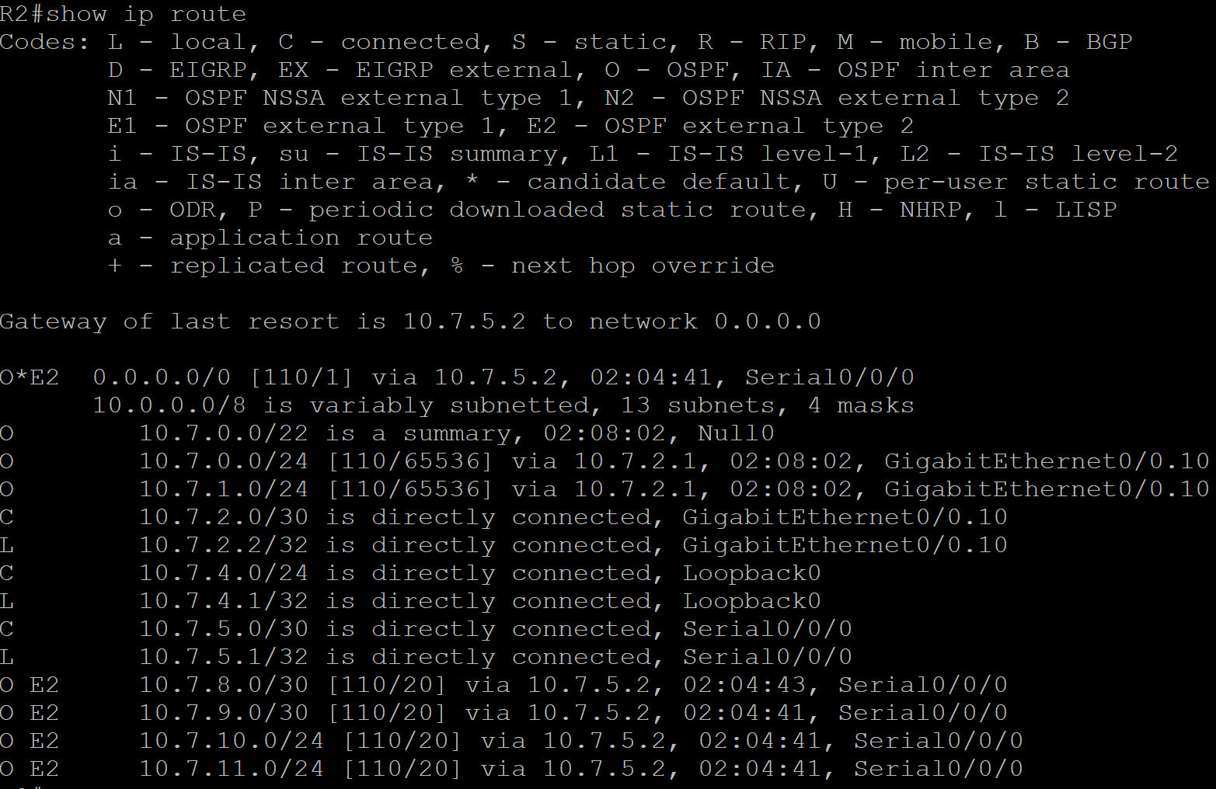



1. **Create a single EIGRP summary route on the R1 interface to R3, summarizing all of the IPv6 routes in the OSPF network as efficiently as possible.**

For IPv6 reachability across OSPF and EIGRP, a summary route similar to the one created for IPv4 is needed for summarizing OSPF areas. We need to advertise IPv6 routes from OSPF by making a summary address that encompasses all subnets used in to EIGRP so the devices participating in EIGRP will have a IPV6 route to the OSPF areas. The command in R1 address family of EIGRP summarizes the IPv6 routes from OSPF to R3.

|  |
| --- |
| CLI Command  R1:  router eigrp CASE2017  address-family ipv6 unicast autonomous-system 7  af-interface Serial0/0/1  **summary-address 2001:DB8:7::/61**  exit-af-interface  exit-address-family |
| R1: Show IPv6 route shows a /61 summary route that was created in R1 |
|  |
| R3: Show IPv6 route shows a /61 summary route that was created in R3 |
|  |

**Task 6: Configure MP-BGP**

1. **The BGP AS number is 650xx, where xx is your 2-digit group number (e.g. 01, 02, 03…10, 11, etc.).**

BGP AS number is configured on R3 and R4 to initialize the process of activating BGP on both routers. BGP process needs to know if the autonomous system number to determine if the router is participating in either iBGP or eBGP process.

|  |
| --- |
| CLI Command for R3 and R4 to initialize BGP AS number  router bgp 65007 |
| **Router 3** |
|  |
| **Router 4** |
|  |

1. **Use router ID x.y.y.y, where x is your group number and y is the router number (e.g. Group 5 would use 5.3.3.3 on R3)**

Router ID in BGP is used to identify the router so when a packet from router is sent to another device, you are able to identify the source of the packet.

|  |
| --- |
| CLI Command for R3 and R4 to initialize BGP router-id number  R3: R4:  router bgp 65007 router bgp 65007  bgp router-id 7.3.3.3 bgp router-id 7.4.4.4 |
| **Router 3** |
|  |
| **Router 4** |
|  |

1. **Configure iBGP neighbor relationships between R3 and R4 as shown in the topology diagram.**

Neighbor relationship is configured on both R3 and R4 to enable an internal BGP session between the two routers. On R3 and R4 an identical autonomous system number is used to issue a iBGP session. Then using a remote-as command using the neighbors IP address is issued to identify the neighbor. Finally, a neighbor activate command is used to activate the session between the two router so both routers can exchange routing information.

|  |
| --- |
| CLI Command for R3 and R4 to initialize iBGP neighbor relationships  **R3:**  **R4:**  router bgp 65007  bgp router-id 7.4.4.4  neighbor 172.16.7.1 remote-as 65007  address-family ipv4  neighbor 172.16.7.1 activate  neighbor 172.16.7.1 next-hop-self  exit-address-family  address-family ipv6  neighbor 172.16.7.1 activate  exit-address-family  router bgp 65007  bgp router-id 7.3.3.3  neighbor 172.16.7.2 remote-as 65007  address-family ipv4  neighbor 172.16.7.2 activate  neighbor 172.16.7.2 next-hop-self  exit-address-family  address-family ipv6  neighbor 172.16.7.2 activate  exit-address-family |
| **Router 3 is neighbors with R4’s 172.16.7.2 network** |
|  |
| **Router 4 is neighbors with R3’s 172.16.7.1 network** |
|  |

1. **Configure R3 and R4 to advertise themselves as the next hop for all IPv4 routes they exchange with each other.**

The “neighbor [neighbor IP address] next-hop-self” command is used to determine the next hop for the routers in the iBGP session. This command forces the routers in the iBGP session to choose the neighbor as the next-hop. Therefore, R3’s next-hop is 172.16.7.2 and R4’s next-hop-self is 172.16.7.1.

|  |
| --- |
| CLI Command for R3 and R4 to advertise themselves as the next hop for all IPv4 routes they exchange with each other.  **R3:**  **R4:**  router bgp 65007  bgp router-id 7.4.4.4  neighbor 172.16.7.1 remote-as 65007  address-family ipv4  neighbor 172.16.7.1 next-hop-self  exit-address-family  router bgp 65007  bgp router-id 7.3.3.3  neighbor 172.16.7.2 remote-as 65007  address-family ipv4  neighbor 172.16.7.2 next-hop-self  exit-address-family |
| **Router 3 is neighbors with R4’s 172.16.7.2 network** |
|  |
| **Router 4 is neighbors with R3’s 172.16.7.1 network** |
|  |

1. **The configuration should use MP-BGP to carry both IPv4 and IPv6 routes (IPv6 will be configured in Task 8).**

The MP-BGP allows the BGP process to create address families in which routers can carry IPv4 and IPv6 routes.

|  |
| --- |
| CLI Command for R3 and R4 showing MP-BGP  **R4:**  router bgp 65007  address-family ipv4  exit-address-family  address-family ipv6  exit-address-family  **R3:**  router bgp 65007  address-family ipv4  exit-address-family  address-family ipv6  exit-address-family |
| **Router 3 – example when IPv4 routes are added in address families.** |
|  |
|  |
| **Router 3 – example when IPv4 routes are added in address families.** |
|  |

1. **Advertise all subnets of the 10.x.0.0/16 networks, except any /32 routes, from R3 to R4. Do not add any static or summary routes to accomplish this.**

This step advertises the entire network comprising of OSPF and EIGRP networks into R4. This is done so R4 has routes to the OSPF and EIGRP networks. To accomplish the advertising of routes into R4, network commands are issued that were learned from R3’s routing table and then the same routes from the routing table are issued in the IPv4 address family of BGP in R3. R4 will now have all of R3’s routes.

|  |
| --- |
| CLI Command to advertise all of the 10.7.0.0/16 network from R3’s routing table to R4  **R3:**  router bgp 65007  bgp router-id 7.3.3.3  neighbor 172.16.7.2 remote-as 65007  address-family ipv4  **network 10.7.0.0 mask 255.255.252.0**  **network 10.7.4.0 mask 255.255.255.0**  **network 10.7.5.0 mask 255.255.255.252**  **network 10.7.8.0 mask 255.255.255.252**  **network 10.7.9.0 mask 255.255.255.252**  **network 10.7.10.0 mask 255.255.255.0**  **network 10.7.11.0 mask 255.255.255.0**  neighbor 172.16.7.2 activate  neighbor 172.16.7.2 next-hop-self  exit-address-family |
| **Router 3** |
|  |
| **Router 4** |
|  |

1. **Also advertise the 172.16.x.0/30 subnet.**

As said in the previous step, all routes available in the routing table of R3 are advertised by IPv4 Address family of BGP. 172.16.7.0/30 was present in R3’s routing table therefore, it must also be advertised to R4. Also this network is also the network used to implement an iBGP session with R4, therefore, this network command is essential to have in the address family of BGP.

|  |
| --- |
| CLI Command to advertise the 172.16.7.0/30 network from R3’s routing table to R4  router bgp 65007  bgp router-id 7.3.3.3  neighbor 172.16.7.2 remote-as 65007  address-family ipv4  **network 172.16.7.0 mask 255.255.255.252**  neighbor 172.16.7.2 activate  neighbor 172.16.7.2 next-hop-self  exit-address-family |
| **Router 3** |
|  |
| **Router 4** |
|  |

1. **Configure R3 to set a Local Preference of 500 on all routes received from R4**

Local preference indicates to routers which path is the best path to exit the autonomous system. In this case we are setting a local preference of 500 on all routes received from R4. Therefore, all routes that are received R4 to R3 will have a local preference of 500. On R3, there is only one route that is received from R4 so its local preference will be 500. Alongside creating a route-map, an inbound attribute on the neighbor is configured to determine that the next hop in R3 will have a local preference of 500.

|  |  |
| --- | --- |
| router bgp 65007  bgp router-id 7.3.3.3  address-family ipv4  **neighbor 172.16.7.2 route-map LOCALPREF in**  exit-address-family  **route-map LOCALPREF permit 10**  **set local-preference 500** | |
| Router 3 |  | |

**Task 7: Configure NAT**

1. Configure NAT on R3 for all IPv4 connections to the Internet. Specifically, use NAT Overload (PAT) so that all outbound connections from 10.**x**.0.0/16 will be translated to the IP address assigned to the s0/1/1 interface of R3.

Configuring NAT overload so that when an outbound connection from 10.7.0.0/16 occurs, it is translated to the s0/1/1 interface of R3. To achieve this, we must first put an access list permitting the 10.7.0.0/16 address on R3. Then we need to define ip nat inside or outside depending on where the interfaces of R3 point. Finally, an overload command appending the access list is needed were it activates NAT Overload on the s0/1/1 interface.

|  |  |
| --- | --- |
| CLI Command to configure NAT Overload  access-list 1 permit 10.7.0.0 0.0.255.255  interface s0/0/0  ip nat inside  interface GigabitEthernet0/0.20  ip nat inside  interface s0/1/1  ip nat outside  ip nat inside source list 1 interface s0/1/1 overload | |
| Ping from R1 | Output in R3. Below the translation results of inside local to inside global, the output is of nat debug to show translations being done. This snippet is an example of a ping from R1 to R3, showing a translation. When R1 (source) pinged to R3 (destination), its address got translated to 203.0.7.1 and in the second line, the destination address (203.0.7.1) is translated back to the source address of R1. Router 3 is tranalation packets in both directions. |
|  |  |

1. Create a static NAT mapping for the IPv4 address of R2's Loopback interface to the global address 203.0.**x**.3

For any device trying connect to 203.0.7.3, their ping will reach the 203.0.7.3 but will be translated to the loopback address of R2 (10.7.4.1). This is an example of one to one mapping where 203.0.7.3 is statically mapped to 10.7.4.1. To accomplish the mapping, we need to define which interfaces on R3 are part of nat inside or out side, then write a command like so, “ip nat inside source static 10.7.4.1 203.0.7.3” to issue a static translation (mapping).

|  |
| --- |
| CLI Command  interface s0/0/0  ip nat inside  interface GigabitEthernet0/0.20  ip nat inside  interface s0/1/1  ip nat outside  ip nat inside source static 10.7.4.1 203.0.7.3 |
| Inside local is R2’s loopback and it is translated to 203.0.7.3 |
|  |

**Task 8: Connecting Pods:**

1. **Create a tunnel interface on R3 running GRE over IPv4. The tunnel source should be s0/1/0 and the destination should be the address of the other pods R3 s0/1/0 interface. Give the tunnel interface the IPv6 address FEC0:1::x/64. The tunnel should not have any IPv4 address.**

Configuring a GRE tunnel over ipv4 with tunnel source and destination address and also configure ipv6 address on the tunnel interface

Purpose of GRE tunnel is to exchange packets using direct connection from one network to other network rather than passing all those packets through public network, which adds the risk of eyes-dropping, DDOS attacks. For tunnel to reach from one network to other network we need to have source and destination for tunnel to work. Also we can assign ipv4 or ipv6 addresses to the tunnel interface

To configure tunnel we enter global configuration mode now, we enter [interface tunnel0] command this will activate the tunnel0 now we will need to configure tunnel source and destination so that our network knows where to reach, right under tunnel0 interface we will add [tunnel source (interface)] command this will create a source through which all packets will go through. To create a Destination for our tunnel we use [tunnel destination (ip address of destination interface)] command to let packets know where to go. No shutdown command is necessary for the tunnel0 so that its status is up and it can be configure under tunnel0 interface using [no shutdown] command. To assign an ipv6 address we use [ipv6 (ipv6-address)] command under tunnel0 interface.

|  |  |
| --- | --- |
| **R3: Proof of tunnel over ipv4 without any ipv4 address configured** | **C:\Users\Yash\Desktop\Case Study\Task 8\Ipv4 tunnel0.PNG** |
| **CLI Commands:** | R3:  interface Tunnel0  tunnel source Serial0/1/0  tunnel destination 172.16.50.1  no shut  exit |
| **R3: Proof of giving tunnel an ipv6 address** | C:\Users\Yash\Desktop\Case Study\Task 8\Ipv6 tunnel0.PNG |
| **CLI Commands:** | R3:  interface Tunnel0  ipv6 address FEC0:1::7/64  no shut  exit |

1. **Configure MP-BGP on both R3 routers and form eBGP neighbor relationships between them using their FEC0:1::/64 addresses. These BGP routers should exchange only IPv6 routes.**

We are forming ebgp neighbor relationships between two-network using ipv6 address

Purpose of forming ebgp relationship is to be able to exchange packets from one network to other since they both are in two different Autonomous system

To configure this we entered bgp mode and then configure neighbor in this situation our neighbor is FEC0:1::50 in the Autonomous System 65050 so the command for this would be [neighbor FECO:1::50] remote-as 65050] this command will let our router R3 know that this is the neighbor that we are connected to in our ebgp neighbor relationship. Since, we only want to exchange ipv6 routes we will go under address family of ipv4 and type in [no neighbor FEC0:1::50 activate] this command will remove ipv4 as a carrier of ipv6 routes of that specific neighbor, and then we will activate it under ipv6 address family using [neighbor FEC0:1::50 activate] command which will make ipv6 passenger and carrier of only ipv6 routes.

|  |  |
| --- | --- |
| **R3: Proof of neighbor relationship between eBGP neighbors** | **C:\Users\Yash\Desktop\Case Study\Task 8\Ipv6 MP-BGP.PNG** |

**CLI Commands:**

|  |
| --- |
| R3:  router bgp 65007  neighbor FEC0:1::50 remote-as 65050  address-family ipv4  no neighbor FEC0:1::50 activate  exit-address-family  address-family ipv6  neighbor FEC0:1::50 activate  exit-address-family |

1. **Advertise all subnets of the 2001:db8:x::/48 from R3 to the other pod, except any /128 routes you may have in your routing table.**

In this step we are advertising our ipv6 routes from R3 to other network’s R3

To advertise you need to enter bgp mode, after that you need to enter into ipv6 address-family, here we will advertise our ipv6 routes using [ network (ipv6-address) ] command this will advertise all its ipv6 addresses to other network’s R3 and it will show up in its routing table

|  |  |
| --- | --- |
| **R3: Proof of advertising ipv6 routes** | **C:\Users\Yash\Desktop\Case Study\Task 8\Ipv6 MP-BGP.PNG** |

**CLI Commands:**

|  |
| --- |
| R3:  router bgp 65007  address-family ipv6  network 2001:DB8:7::/64  network 2001:DB8:7:1::/64  network 2001:DB8:7:2::/64  network 2001:DB8:7:4::/64  network 2001:DB8:7:5::/64  network 2001:DB8:7:8::/64  network 2001:DB8:7:9::/64  network 2001:DB8:7:10::/64  network 2001:DB8:7:11::/64  network 2001:DB8:7:ABCD::/64  exit-address-family |

1. **Form an eBGP neighbor relationship between R4 on your pod an R4 on the other pod. This relationship should be made using the IPv4 addresses on your Gi0/0/1.10 interfaces.**

To accomplish this step we will need to form ebgp relationship between R4 and other network’s R4 using Ipv4 address

To configure this task we first enter bgp mode then, use [neighbor 199.212.32.50 remote-as 65050] command to advertise our bgp neighbor who is in a different Autonomous System. Once we have advertised our neighbor we will have to enter ipv4 address-family and type [neighbor 199.212.32.50 next-hop-self] command to accept all ebgp routes and advertise them into ibgp.

**CLI Commands:**

|  |
| --- |
| R4:  router bgp 65007  neighbor 199.212.32.50 remote-as 65050  address-family ipv4  neighbor 199.212.32.50 activate  neighbor 199.212.32.50 next-hop-self  exit-address-family |

|  |  |
| --- | --- |
| **R3: Proof of advertising ipv6 routes** | **C:\Users\Yash\Desktop\Case Study\Task 8\Ipv6 MP-BGP.PNG** |

1. **Advertise all IPv4 routes available on R4 to the other group via MP-BGP.**

In this step we are advertising our ipv4 routes from R4 to other network’s R4

To advertise you need to enter bgp mode, after that you will need to enter into ipv4 address-family, here we will advertise our ipv4 routes using [ network (ipv4-address) ] command this will advertise all its ipv4 addresses to other network’s R4 and it will show up in its routing table meaning that it has learned all the routes we have advertised

|  |  |
| --- | --- |
| **R4: Proof of advertising ipv4 routes** | **C:\Users\Yash\Desktop\Case Study\Task 8\Second Last step.PNG** |

**CLI Commands:**

|  |
| --- |
| R4:  router bgp 65007  address-family ipv4  network 10.7.0.0 mask 255.255.252.0  network 10.7.4.0 mask 255.255.255.0  network 10.7.5.0 mask 255.255.255.252  network 10.7.8.0 mask 255.255.255.252  network 10.7.9.0 mask 255.255.255.252  network 10.7.10.0 mask 255.255.255.0  network 10.7.11.0 mask 255.255.255.0  exit-address-family |

1. **Configure R4 to set the MED to 50 on all IPv4 routes sent to the other pod.**

In this step we will configure MED to 50 for all ipv4 routes sent to the other network, this will notify other network about which enter point or path it should prefer when enter into my network.

To configure MED metric to 50 we first create a route map using [route-map MED permit 10] command to specify from what place you can send your routes to, under that command you will need to set med metric to 50 [set metric 50]. In the next, we enter bgp mode and then enter into our ipv4 address-family since we are only configuring MED 50 to all ipv4 routes. In our last step we will specify where are we using our route-map which is on our neighbors ip address so it will know that it have to use that path to come back to my network, command for that would be [neighbor 199.212.32.50 route-map MED out]

**CLI Commands:**

|  |
| --- |
| R4:  route-map MED permit 10  set metric 50  exit  router bgp 65007  address-family ipv4  neighbor 199.212.32.50 route-map MED out  exit-address-family  exit |

**Task 9: Testing**

R2-VRF

foreach address {

203.0.7.3

203.0.7.2

203.0.7.1

10.7.0.1

10.7.1.1

10.7.2.1

10.7.2.2

10.7.4.1

10.7.5.1

10.7.5.2

10.7.8.1

10.7.8.2

10.7.9.1

10.7.9.2

10.7.10.1

10.7.11.1

172.16.7.1

172.16.7.2

2001:db8:7:0::1

2001:db8:7:1::1

2001:db8:7:2::1

2001:db8:7:2::2

2001:db8:7:4::1

2001:db8:7:5::1

2001:db8:7:5::2

2001:db8:7:8::1

2001:db8:7:8::2

2001:db8:7:9::1

2001:db8:7:9::2

2001:db8:7:10::1

2001:db8:7:11::1

2001:db8:7:abcd::1

2001:db8:7:abcd::2

} { ping vrf VRF-EIGRP $address }

R2-VRF: IPv4

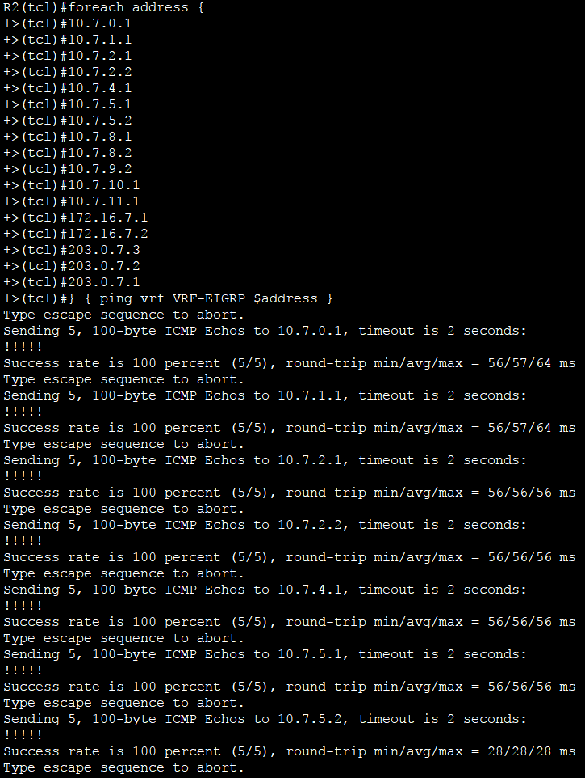

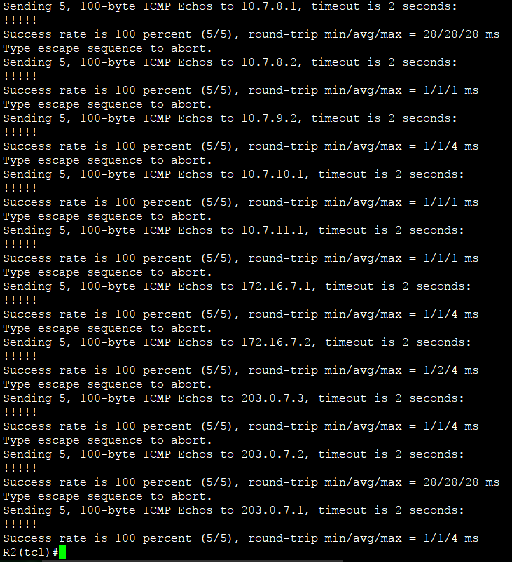

R2-VRF: IPv6

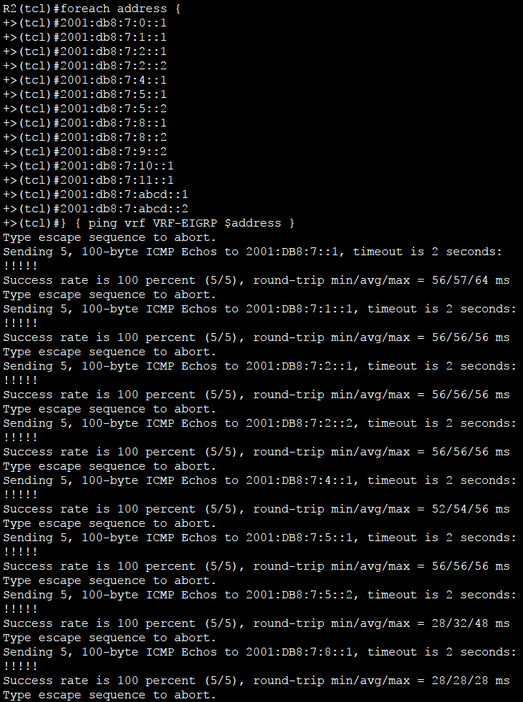

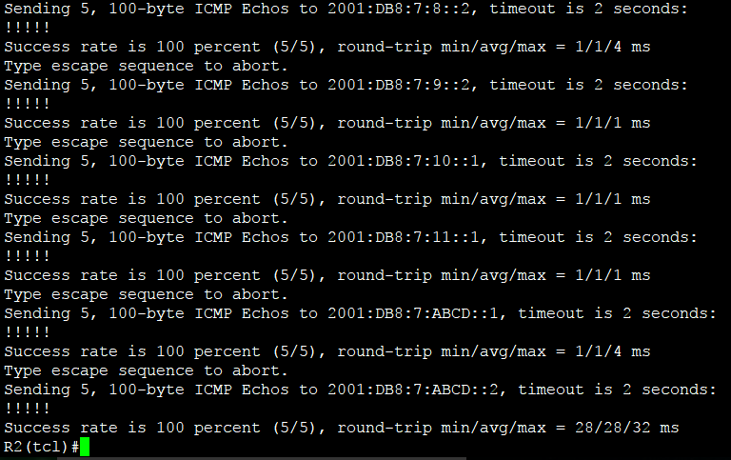

R1,R2, R3

foreach address {

10.7.0.1

10.7.1.1

10.7.2.1

10.7.2.2

10.7.4.1

10.7.5.1

10.7.5.2

10.7.8.1

10.7.8.2

10.7.9.1

10.7.9.2

10.7.10.1

10.7.11.1

172.16.7.1

172.16.7.2

203.0.7.1

203.0.7.2

203.0.7.3

2001:db8:7:0::1

2001:db8:7:1::1

2001:db8:7:2::1

2001:db8:7:2::2

2001:db8:7:4::1

2001:db8:7:5::1

2001:db8:7:5::2

2001:db8:7:8::1

2001:db8:7:8::2

2001:db8:7:9::1

2001:db8:7:9::2

2001:db8:7:10::1

2001:db8:7:11::1

2001:db8:7:abcd::1

2001:db8:7:abcd::2

} { ping $address }

R1: IPv4

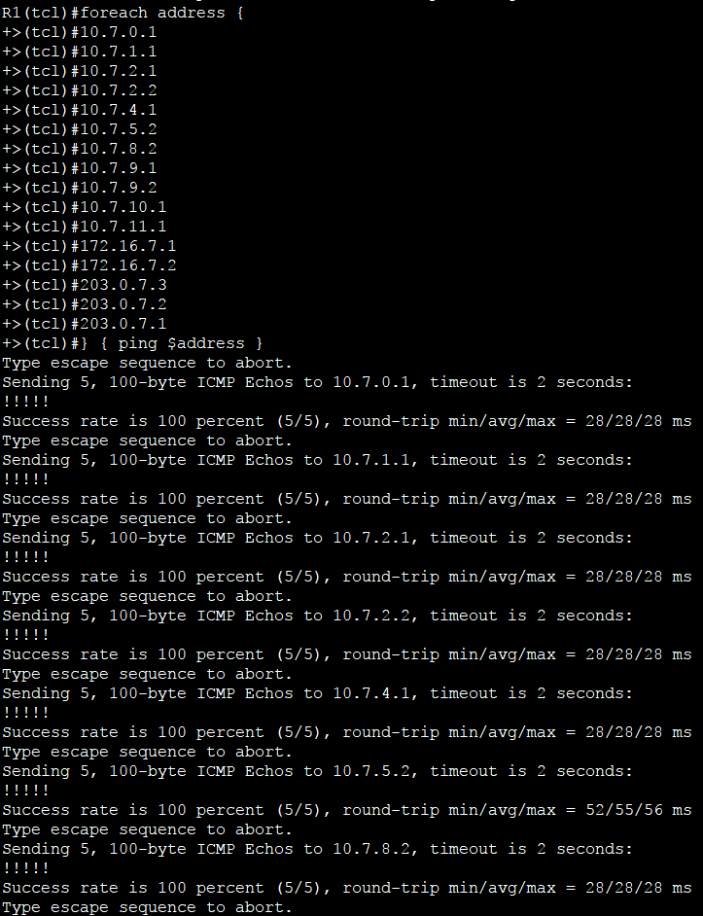

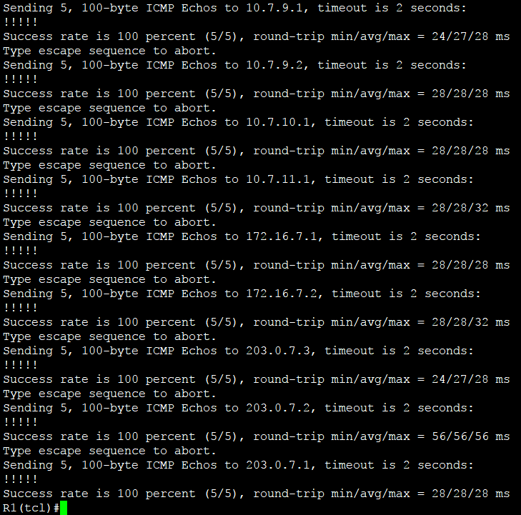

R1: IPv6

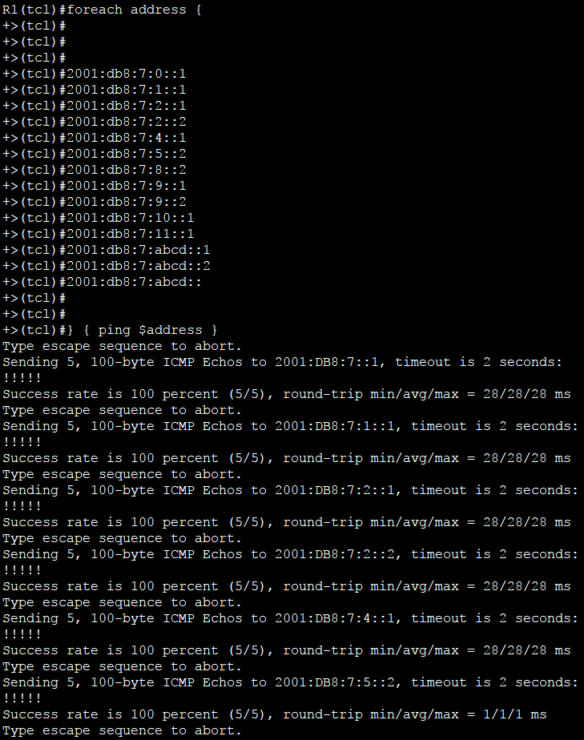

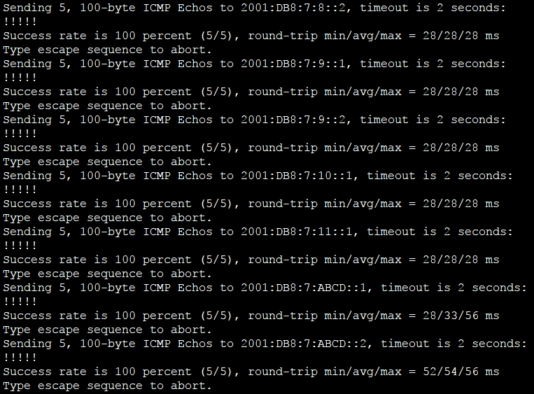

R2: IPv4

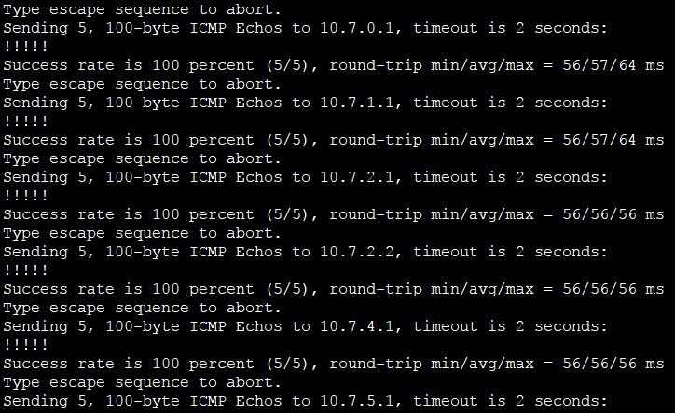

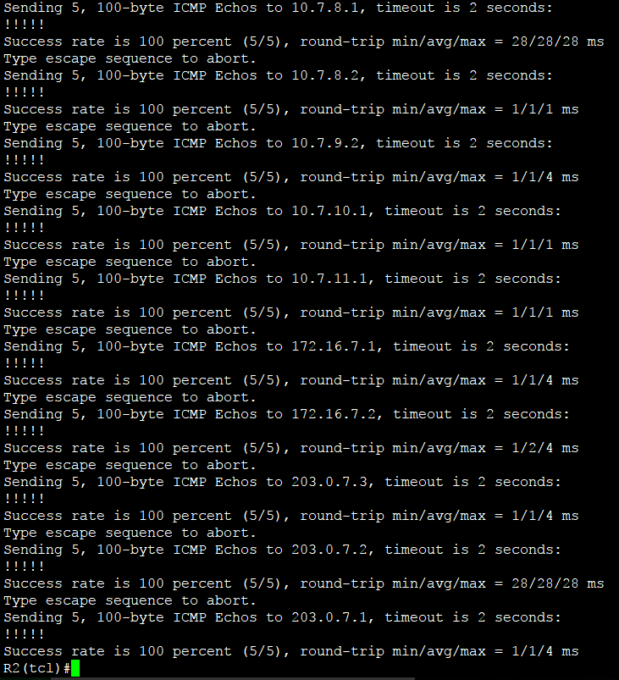

R2: IPv6

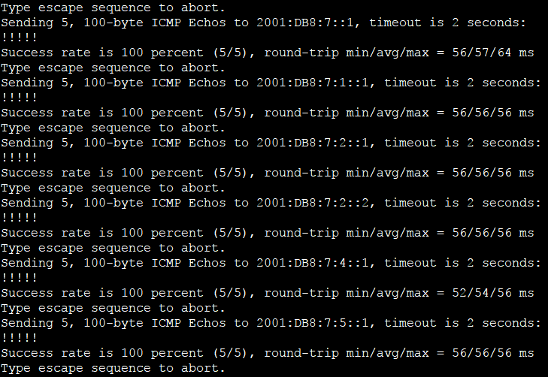



R4

foreach address {

10.7.0.1

10.7.1.1

10.7.2.1

10.7.2.2

10.7.4.1

10.7.5.1

10.7.5.2

10.7.8.1

10.7.8.2

10.7.9.1

10.7.9.2

10.7.10.1

10.7.11.1

172.16.7.1

172.16.7.2

} { ping $address }

R4 IPv4

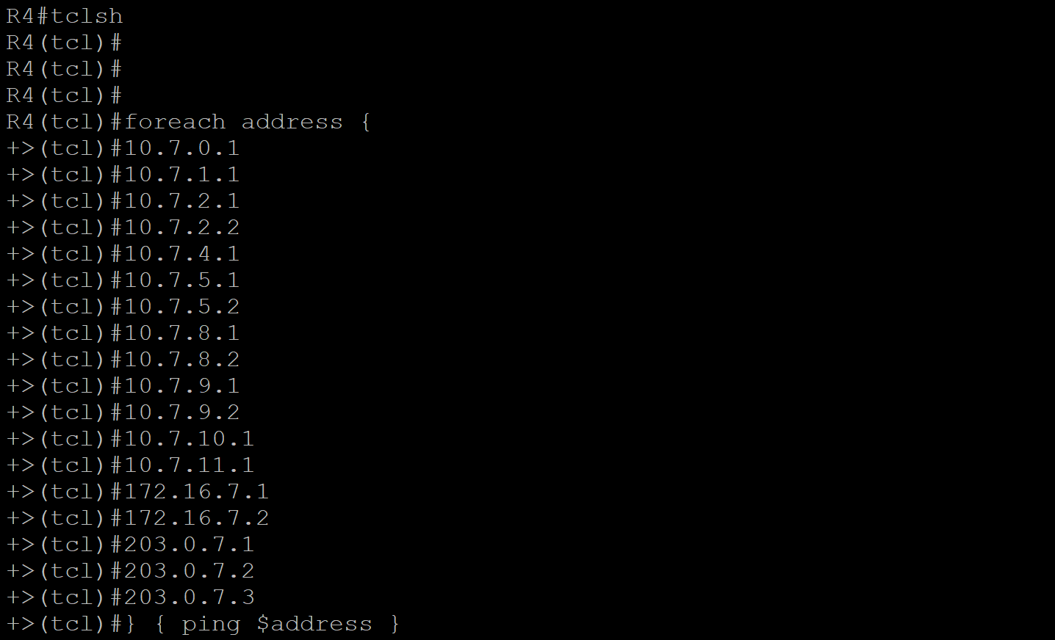



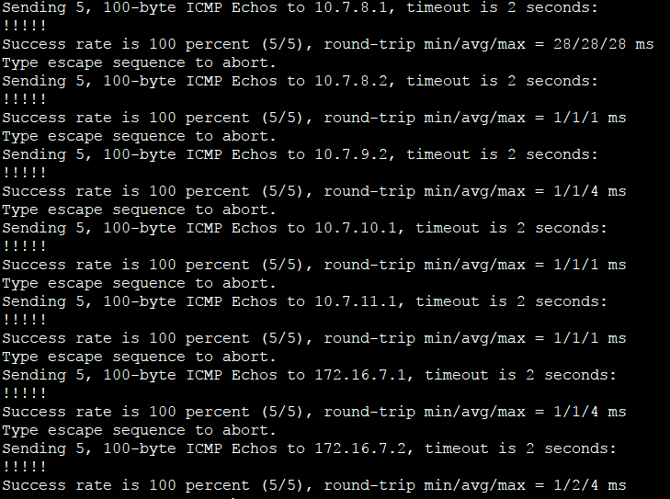

R4-VRF

foreach address {

203.0.7.3

2001:db8:7:0::1

2001:db8:7:1::1

2001:db8:7:2::1

2001:db8:7:2::2

2001:db8:7:4::1

2001:db8:7:5::1

2001:db8:7:5::2

2001:db8:7:8::1

2001:db8:7:8::2

2001:db8:7:9::1

2001:db8:7:9::2

2001:db8:7:10::1

2001:db8:7:11::1

2001:db8:7:abcd::1

2001:db8:7:abcd::2

} { ping vrf VRF-INET $address }

R4 IPV6 VRF-INET

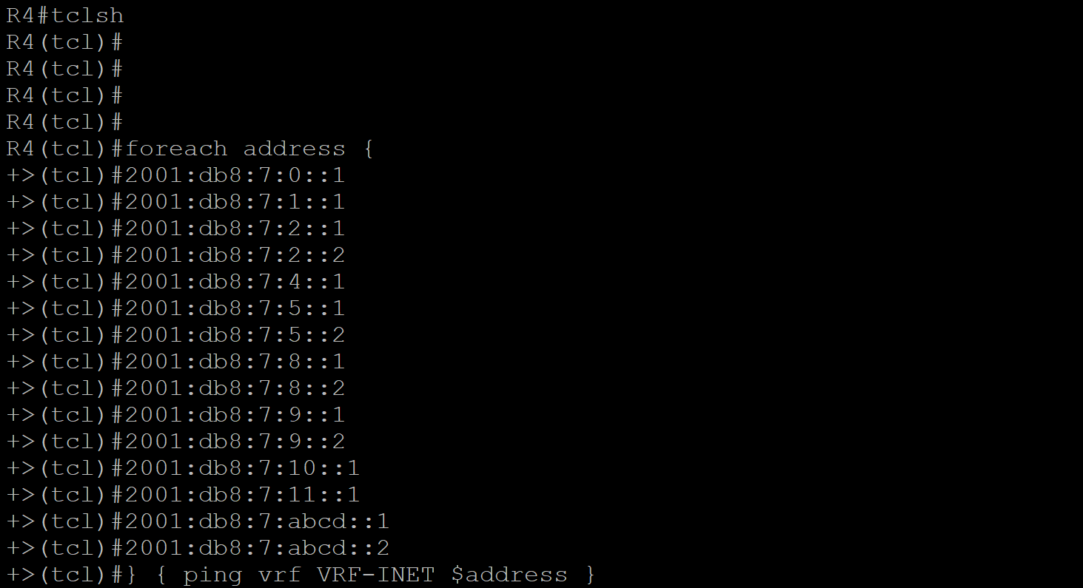





Josh’s Network:

foreach address {

10.50.0.1

10.50.1.1

10.50.2.1

10.50.4.1

10.50.5.1

10.50.6.1

10.50.128.1

10.50.129.1

10.50.130.1

172.16.50.1

2001:db8:50:0::1

2001:db8:50:1::1

2001:db8:50:2::1

2001:db8:50:4::1

2001:db8:50:8::1

2001:db8:50:80::1

2001:db8:50:81::1

2001:db8:50:82::1

fec0:1::50

} { ping $address }

R3: To Josh’s network

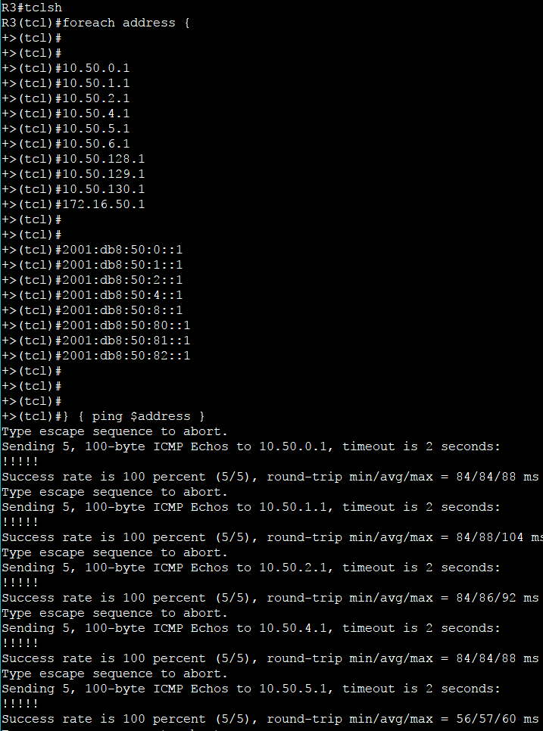

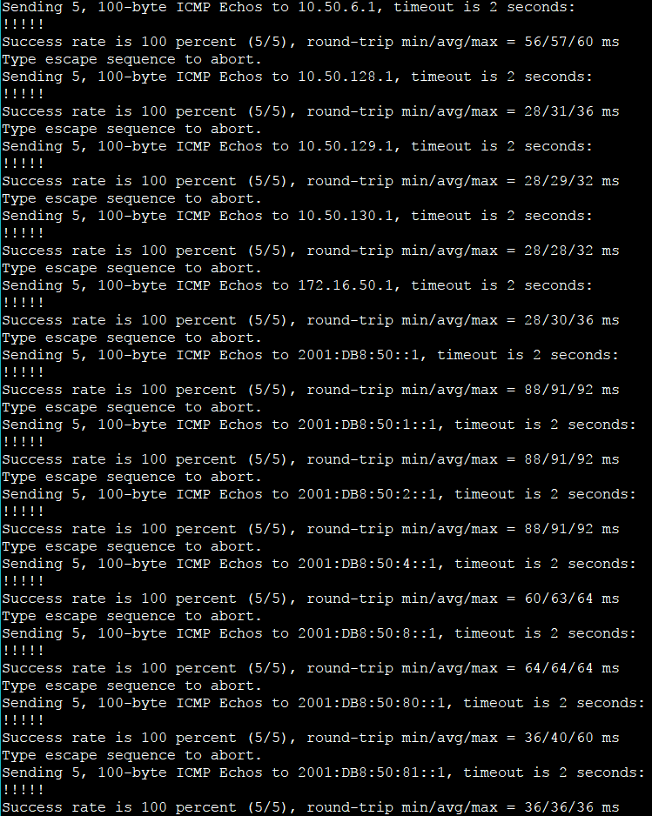

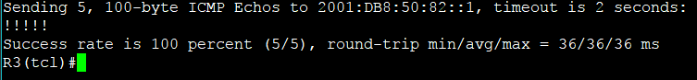

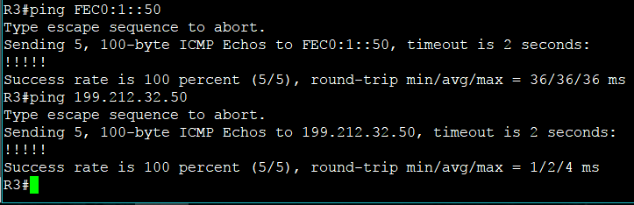

R3-VRF

foreach address {

10.7.0.1

10.7.1.1

10.7.2.1

10.7.2.2

10.7.4.1

10.7.5.1

10.7.5.2

10.7.8.1

10.7.8.2

10.7.9.1

10.7.9.2

10.7.10.1

10.7.11.1

172.16.7.1

172.16.7.2

203.0.7.1

203.0.7.2

203.0.7.3

2001:db8:7:0::1

2001:db8:7:1::1

2001:db8:7:2::1

2001:db8:7:2::2

2001:db8:7:4::1

2001:db8:7:5::1

2001:db8:7:5::2

2001:db8:7:8::1

2001:db8:7:8::2

2001:db8:7:9::1

2001:db8:7:9::2

2001:db8:7:10::1

2001:db8:7:11::1

2001:db8:7:abcd::1

2001:db8:7:abcd::2

} { ping vrf VRF-OSPF $address }

R3-VRF

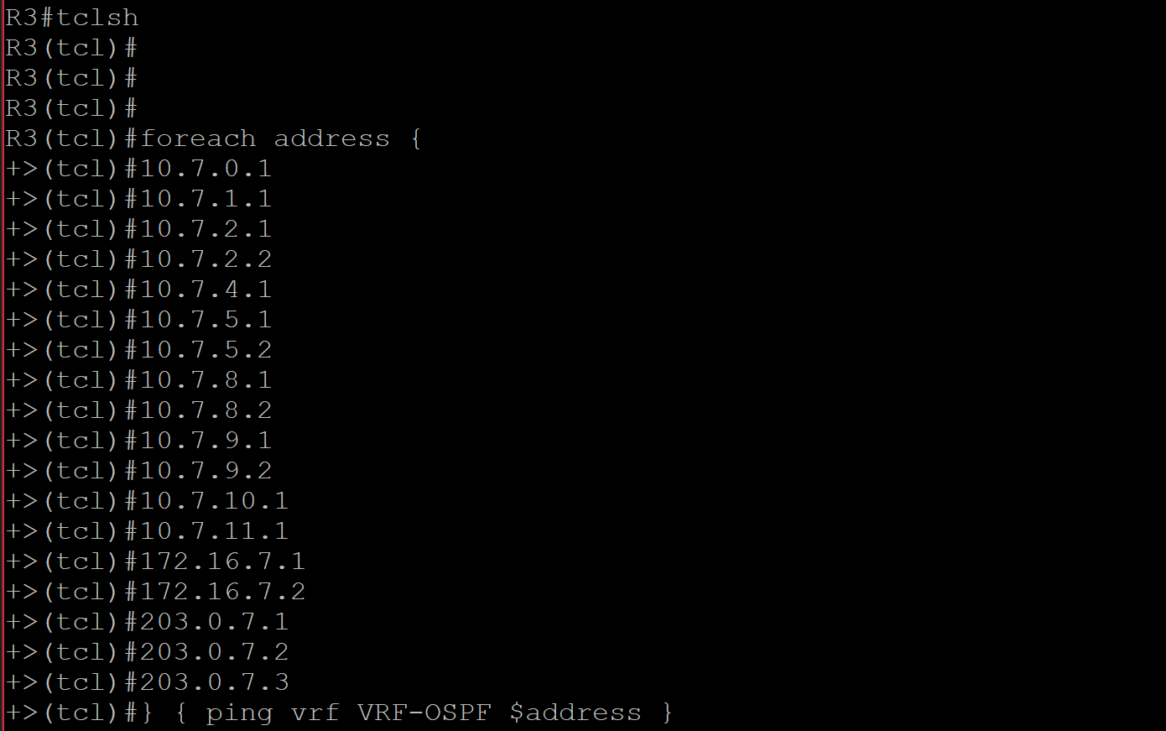





R3 VRF- IPv6

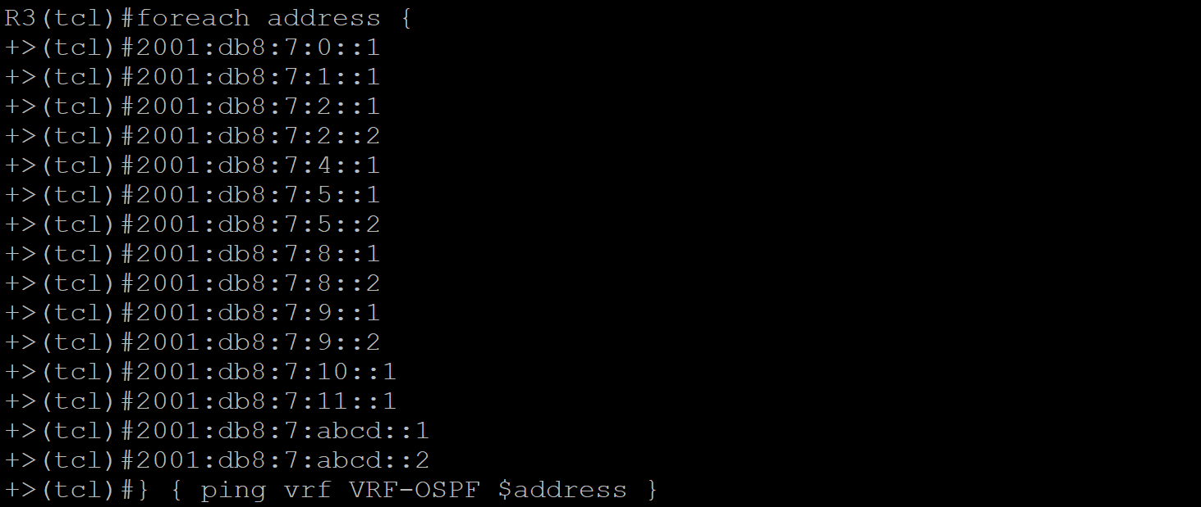



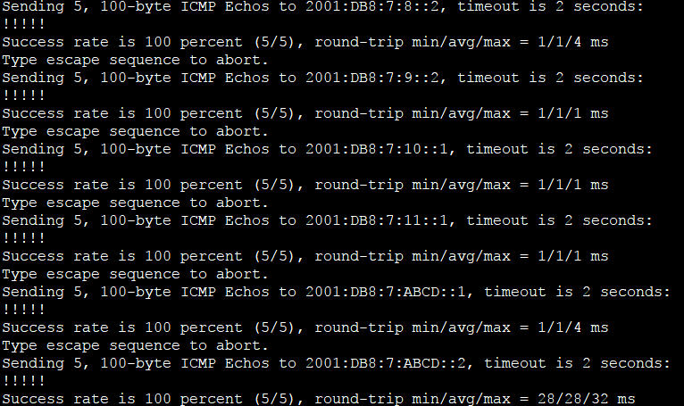

* **A web server has been configured to respond to HTTP requests on 198.51.100.1 port 80. From R3, in the VRF-OSPF VRF, telnet to this address on port 80, type GET, and verify that you**

**receive a web response.**

|  |
| --- |
| **CLI Command:** First you need to enter exec mode  Telnet 199.51.100.1 80 |

**Security Features for Routing Protocols**

EIGRP MD5 Authentication

1. What the chosen security feature does
   * All routers participating in EIGRP will have message authentication when they communicate. They will only become neighbors if both routers have identical message authentication. This is done so it prevents malicious routing information being introduced in the routing domain of the EIGRP router.

1. Why you chose this specific feature
   * This prevents a security vulnerability where an attacker may try to form neighbor relationship between a router participating in EIGRP. EIGRP will not accept neighbor relationships if the authentication does not match on either ends of the routers.
2. Where you implemented the feature in your network
   * The interfaces in EIGRP named mode had implementation of authentication. It is configured for IPv4 and IPv6.
3. The configurations you used to implement this feature

The first step in authenticating the messages in EIGRP is by creating the keychain and key and then finally the configuration of EIGRP authentication using the keychain and the key.

|  |  |
| --- | --- |
| R1 | R2-VRF |
| key chain EIGRP1  key 1  key-string 0987654321  exit  **router eigrp CASE2017**    address-family ipv4 unicast autonomous-system 7    af-interface Serial0/0/1  **authentication mode md5**  **authentication key-chain EIGRP1**  exit-af-interface      address-family ipv6 unicast autonomous-system 7    af-interface Serial0/0/1  **authentication mode md5**  **authentication key-chain EIGRP1**    exit-address-family | key chain EIGRP1  key 1  key-string 0987654321  exit  router eigrp CASE2017    address-family ipv4 unicast vrf VRF-EIGRP autonomous-system 7      af-interface GigabitEthernet0/0.20  **authentication mode md5**  **authentication key-chain EIGRP2**  exit-af-interface  exit-address-family    address-family ipv6 unicast vrf VRF-EIGRP autonomous-system 7    af-interface GigabitEthernet0/0.20  **authentication mode md5**  **authentication key-chain EIGRP2**  exit-af-interface |
| R3 | |
| key chain EIGRP3  key 1  key-string 0987654321  exit  router eigrp CASE2017  address-family ipv6 unicast autonomous-system 7  af-interface GigabitEthernet0/0.20  **authentication mode md5**  **authentication key-chain EIGRP3**  bandwidth-percent 64  exit-af-interface  af-interface Serial0/0/0  **authentication mode md5**  **authentication key-chain EIGRP3**  bandwidth-percent 64  exit-af-interface  exit-address-family  address-family ipv6 unicast autonomous-system 7  af-interface GigabitEthernet0/0.20  **authentication mode md5**  **authentication key-chain EIGRP3**  bandwidth-percent 64  exit-af-interface  af-interface Serial0/0/0  **authentication mode md5**  **authentication key-chain EIGRP3**  bandwidth-percent 64  exit-af-interface  exit-address-family | |

Link State Database Overload Protection

1. What the chosen security feature does
   * This features limits the routers participating in OSPF to generate non-self LSA’s. Routers generate this type of LSA when routers are misconfigured and because of that they may generate high level of LSAs. This may “overload” the CPU and memory and potentially cause shortages. When this protection is enabled, routers keep a count of non-self generated LSA’s received. When the count of the LSA’s exceed the limit set for received non-self LSA’s the router may shut down the OSPF process and clear the OSPF database. This can be configured in many ways for example a router does not have to shut down its OSPF process, it may just display a warning message.
2. Why you chose this specific feature
   * Routers can potentially in a big network may sometimes be misconfigured and therefore may create a high level of non-self generated LSA’s and may potentially take down the network because of high CPU and memory usage. Therefore, it is best to keep such an action that handles this overload. Hence, why the name of the security feature is overload protection.
3. Where you implemented the feature in your network
   * This is configured after defining OSPFv3 process on the router.
4. The configurations you used to implement this feature

|  |
| --- |
| R1 |
| router ospfv3 7  max-lsa 100 ignore-time 5 ignore-count 3 reset-time 5 |
| R2 |
| router ospfv3 7  max-lsa 100 ignore-time 5 ignore-count 3 reset-time 5 |
| R3 |
| router ospfv3 7  max-lsa 100 ignore-time 5 ignore-count 3 reset-time 5 |

This configuration will allow 100 non-self generated under their ospfv3 process. After exceeding the max-lsa count of 100, the OSPF process will ignore all neighbors for 5 minutes, then after the neighbors are for 5 minutes the OSPF process will be in placed in ignored state for consequent count of 3 times and finally when the ignore count is 0, the reset time of OSPF process is set to 5 minutes. After reset time is over OSPF can perform its process.

BGP TTL Security Check

1. What the chosen security feature does
   * BGP (Time-To-Live) Security Check takes hop count into account for protection an eBGP session. eBGP will only allow neighbor relationships to form if the set hop count matches in the neighbor statement configured under the BGP process. BGP will maintain its session with a external BGP network only if the TTL value in the IP packet header is more than the TTL value configured for the current peering session. If the value is more than the configured value, BGP will not create a ICMP message and also the packet will be discarded silently.
2. Why you chose this specific feature
   * This feature protects against attackers who want to gain connection to a BGP network and perform malicious activity.
3. Where you implemented the feature in your network
   * This feature is implemented under the declaration of BGP process.
4. The configurations you used to implement this feature

|  |
| --- |
| Router 3 |
| router bgp 65007  neighbor 199.212.32.50 ttl-security hops 2 |

This is configured such that the hop count is set to 2 and only allow BGP to accept the packet header with a TTL count of equal or greater than 253. If the neighbor 199.212.32.50 is more than 2 hops away the eBGP peering session will not commence.

**Security Features for the Network**

Unicast Reverse Path Forwarding (uRPF)

1. What the chosen security feature does
   * This security tries to maintain legit traffic on the network. Upon configuration of this feature on per interface basis on each router, the router will verify that the source of any packets received is actually in the Cisco Express Forwarding table and also reachable via the routing table.
2. Why you chose this specific feature
   * This feature is chosen simply for that fact that it prevents malicious traffic on the network.
3. Where you implemented the feature in your network
   * This feature is implemented on a per interface basis on each router.
4. The configurations you used to implement this feature

The configuration is done so that the source of each packet is verified in the CEF and the routing table. Also the configuration is done in loose mode meaning the source IP of the received packet must be in the routing table of the router. There is an option to configure in strict mode but it might drop legitimate packets if asymmetric paths are present in the network. Therefore, to be on the safe side if the network were to have a asymmetric path in the network it is best to use loose mode.

CLI commands to configure uRPF on a per-interface-basis

|  |
| --- |
| R1 |
| Interfaces s0/0/0  ip verify unicast source reachable-via any  interface s0/0/1  ip verify unicast source reachable-via any |
| R2 |
| Interface gi0/0.10  ip verify unicast source reachable-via any  Interface gi0/0.20  ip verify unicast source reachable-via any  Interfaces s0/0/0  ip verify unicast source reachable-via any |
| R3 |
| Interface gi0/0.10  ip verify unicast source reachable-via any  Interface gi0/0.20  ip verify unicast source reachable-via any  Interfaces s0/0/0  ip verify unicast source reachable-via any  Interfaces s0/1/0  ip verify unicast source reachable-via any  Interfaces s0/1/1  ip verify unicast source reachable-via any |
| R4 |
| Interface gi0/0/1.10  ip verify unicast source reachable-via any  Interface gi0/0/1.20  ip verify unicast source reachable-via any  Interfaces s0/1/0  ip verify unicast source reachable-via any  Interfaces s0/1/1  ip verify unicast source reachable-via any |

Logging Implementation

1. What the chosen security feature does
   * One of the most basic and important security feature is Logging. This feature logs any type of traffic on the network. May it be unusual or legitimate. It helps determine network problems that may occur on the network.
2. Why you chose this specific feature
   * This feature is chosen to monitor traffic on the network. At this point in time, social engineering is a big threat to networks and to overcome that our first line of defence should be logging to in future we can prevent something malicious. The purpose of this feature is to track legitimate traffic also so network administrators can identify improper functionality on devices.

1. Where you implemented the feature in your network
   * This feature is implemented on each router in global config mode.
2. The configurations you used to implement this feature

|  |
| --- |
| R1 |
| enable  configure terminal  service timestamps log datetime |
| R2 |
| enable  configure terminal  service timestamps log datetime |
| R3 |
| enable  configure terminal  service timestamps log datetime |
| R4 |
| enable  configure terminal  service timestamps log datetime |

Each log created on devices will come with a date and time to specify at what point in date and time the log occurred on the network.

SSHv2:

1. What the chosen security feature does

* SSHv2 provides strong security using Diffie-Hellman key. It generates 3DES and AES keys to transport packets from one router to other, it also provide Massage Authentication Code (MAC) for integrity check every time a unauthorized packets are being sent towards that specific network, and it records all failed unauthorized attempts made. We can also create ACLs to strengthen the security of the network; you can explicitly deny or permit any address you want. Once, the packet reaches the point of security firstly, keys comparison will take place to see if it is an authenticated packet has been sent and, then it will be matched with ACL list. Therefore, even if someone tries to spoof the network and that spoofed address is not in the ACL list then, that packet will not pass that checkpoint. This increase overall security of our network.

1. Why you chose this specific feature

* It provides better security then Telnet, and SSHv1, which are introduce to vulnerabilities, and keys are easily crackable but SSHv2 uses 3DES and AES to generate keys, which are two of the most secure key generator in present time.

1. Where you implemented the feature in your network

* SSHv2 will be implemented on R3 and R4 because, on R3 we have a tunnel connection with some other network and on R4 we are connected to other network using BGP protocol

1. The configurations you used to implement this feature

|  |
| --- |
| R3 |
| Enable  configure terminal  ip ssh version 2  ip access-list standard PERMIT-SSH  remark ACL permitting SSH to hosts on the Management LAN  permit 10.0.0.0 0.0.0.255  deny any log  exit  line vty 0 4  transport input ssh  access-class PERMIT-SSH in  end |
| R4 |
| Enable  configure terminal  ip ssh version 2  ip access-list standard PERMIT-SSH  remark ACL permitting SSH to hosts on the Management LAN  permit 10.0.0.0 0.0.0.255  deny any log  exit |

**Additional Changes in the Network**

One of the two things that can be changed is not having both OSPF and EIGRP on the network at this point in time when the network is already small. Depending on the type of network or how far the Agency wants to scale their network its best to stick to one routing protocol for internal routing. At the current point in time, the company’s network is small and therefore should only one IGP protocol to maintain simplicity. EIGRP is the best shout at this point to have over the network replacing OSPF because EIGRP is flat and only uses one area. However, when the company begins to scale and becomes more complex, they can think to add OSPF and use areas to segment the network and make it simplistic. Therefore, it depends on the company on what type of network they decide to keep. This does not mean BGP will not be used in the network. BGP is an integral part of the network as it has the ability connects to external routing domains.

Second thing that we can implement in this topology is multiple direct connections between two routers to increase redundancy